**VISVESVARAYA TECHNOLOGICAL UNIVERSITY**

**“JnanaSangama”, Belgaum -590014, Karnataka.**



**LAB REPORT**

**on**

# COMPUTER NETWORKS

***Submitted by***

**Pradyumna Rao (1BM21CS131)**

***in partial fulfillment for the award of the degree of***

**BACHELOR OF ENGINEERING**

***in***

## COMPUTER SCIENCE AND ENGINEERING



**B.M.S. COLLEGE OF ENGINEERING**

**(Autonomous Institution under VTU)**

**BENGALURU-560019**

**June-2023 to September-2023**

**B. M. S. College of Engineering,**

**Bull Temple Road, Bangalore 560019**

(Affiliated To Visvesvaraya Technological University, Belgaum)

### Department of Computer Science and Engineering



**CERTIFICATE**

This is to certify that the Lab work entitled “COMPUTER NETWORKS” carried out by

**POOJASHREE K V(1BM21CS129),** who is bonafide student of **B.M.S. College of**

**Engineering.** It is in partial fulfillment for the award of **Bachelor of Engineering in Computer Science and Engineering** of the Visvesvaraya Technological University, Belgaum during the academic semester June-2023 to September-2023. The Lab report has been approved as it satisfies the academic requirements in respect of a **COMPUTER NETWORKS (22CS4PCCON)** work prescribed for the said degree.

**Swathi Sridharan** **Dr. Jyothi S Nayak**

Assistant Professor Professor and Head

Department of CSE Department of CSE

BMSCE, Bengaluru BMSCE, Bengaluru

**INDEX SHEET**

|  |  |  |
| --- | --- | --- |
| **Experiment No.** | **Title** | **Page number** |
|  | **CYCLE 1** |  |
| **1** | Create a topology and simulate sending a simple PDU from source to destination using hub and switch as connecting devices and demonstrate ping message. | **6-8** |
| **2** | Configure IP address to routers in packet tracer. Explore the following messages: ping responses, destination unreachable, request timed out, reply | **9-13** |
| **3** | Configure default route, static route to the Router | **14-16** |
| **4** | Configure DHCP within a LAN and outside LAN. | **17-19** |
| **5** | Configure RIP routing Protocol in Routers | **20-22** |
| **6** | Configure OSPF routing protocol | **23-25** |
| **7** | Demonstrate the TTL/ Life of a Packet | **26-28** |
| **8** | Configure Web Server, DNS within a LAN. | **29-30** |
| **9** | To construct simple LAN and understand the concept and operation of Address Resolution Protocol (ARP) | **31-32** |
| **10** | To understand the operation of TELNET by accessing the router in server room from a PC in IT office | **33-35** |
| **11** | To construct a VLAN and make the PC’s communicate among a VLAN | **36-38** |
| **12** | To construct a WLAN and make the nodes communicate wirelessly | **39-41** |
|  | **CYCLE 2** |  |
| **13** | Write a program for error detecting code using CRCCCITT (16-bits). | **42-45** |
| **14** | Write a program for congestion control using Leaky bucket algorithm. | **46-47** |
| **15** | Using TCP/IP sockets, write a client-server program to make client sending the file name and the server to send back the contents of the requested file if present | **48-50** |
| **16** | Using UDP sockets, write a client-server program to make client sending the file name and the server to send back the contents of the requested file if present. | **51-53** |
| **17** | Tool Exploration -Wireshark | **54-55** |

**Course Outcomes**

|  |  |
| --- | --- |
| **CO1** | Apply the fundamental concepts of communication in networking. |
| **CO2** | Analyze the various protocols, techniques in TCP/IP network architectur |
| **CO3** | Develop programs that demonstrate the functionalities of physical, Data Link, Network, Transport or Application layer |

**Experiment 1**

**Create a topology and simulate sending a simple PDU from source to destination using hub and switch as connecting devices and demonstrate ping message.**

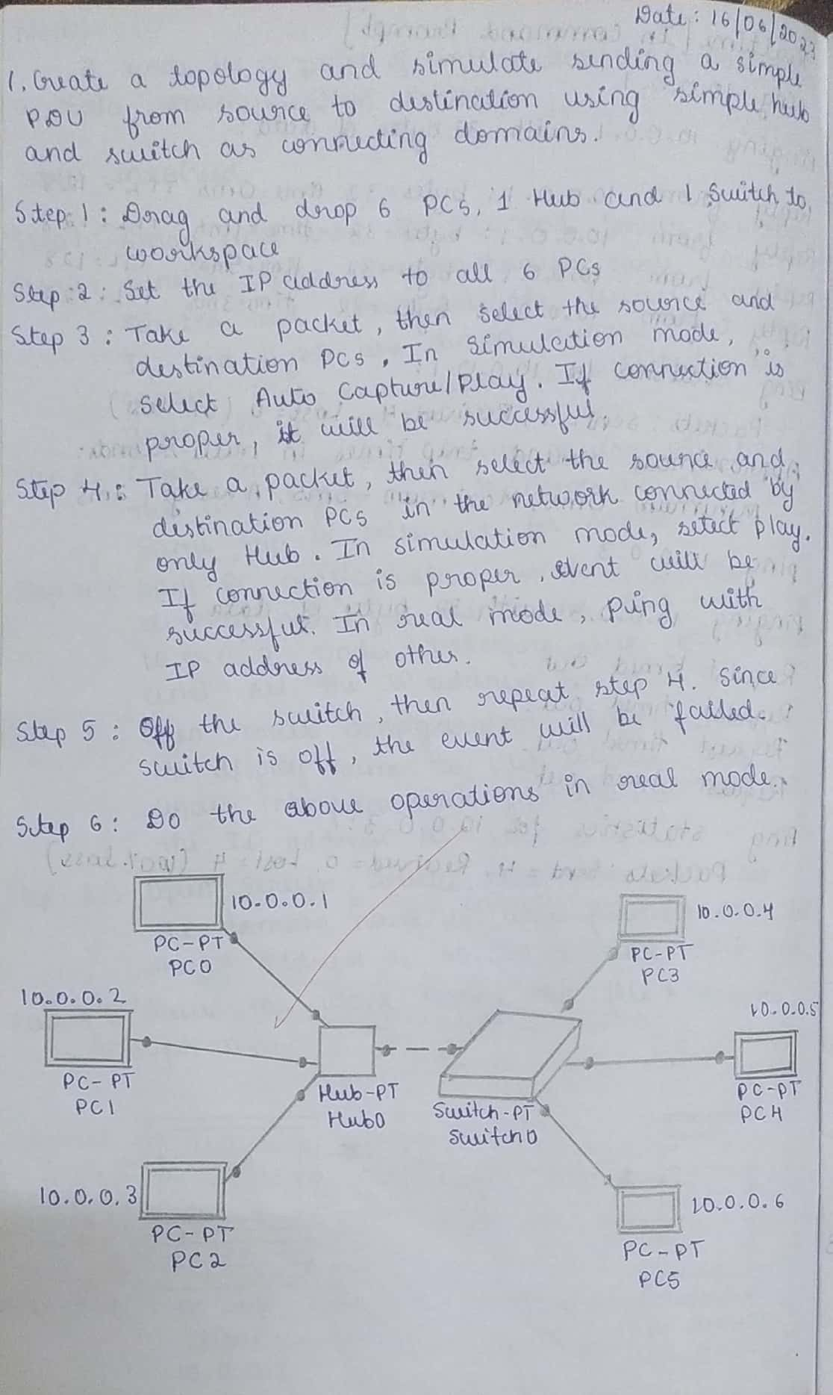

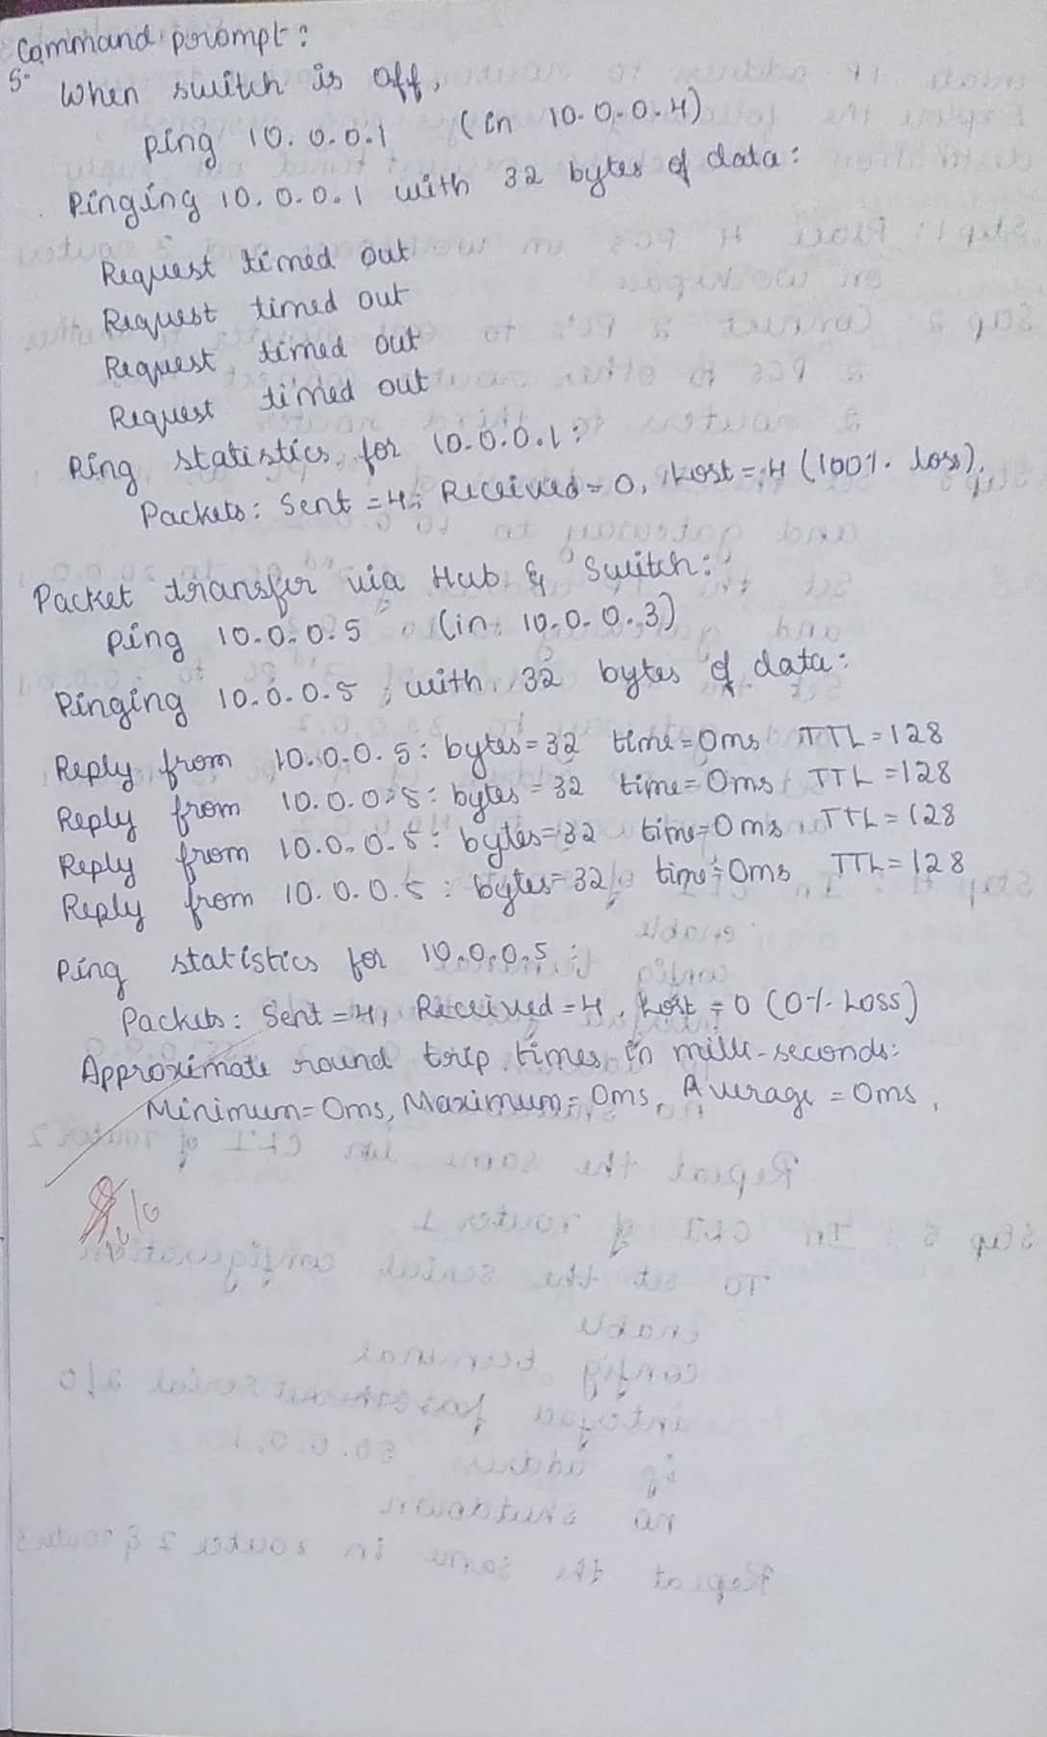

**Topology:**

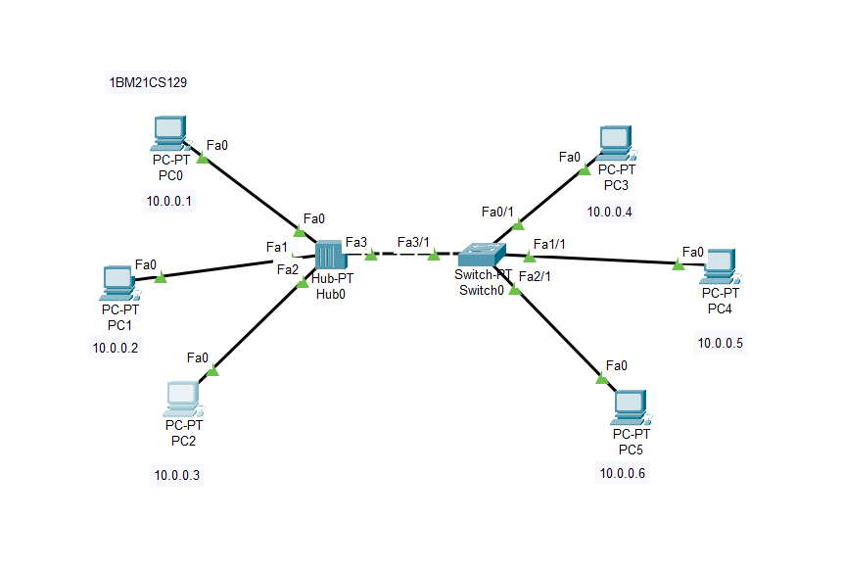

**Output:**

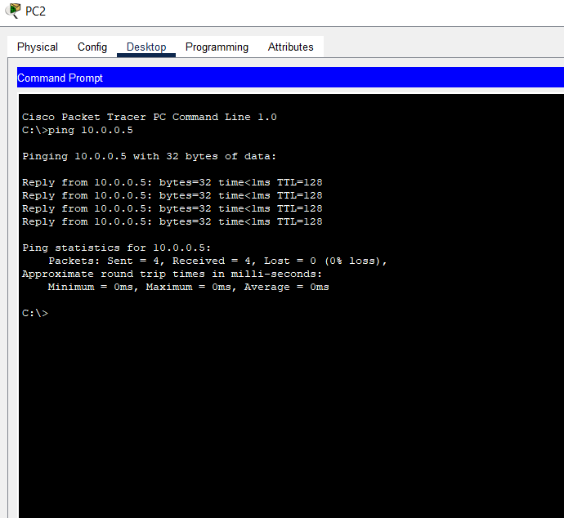

**Experiment 2**

**Configure IP address to routers in packet tracer. Explore the following messages: ping responses, destination unreachable, request timed out, reply**

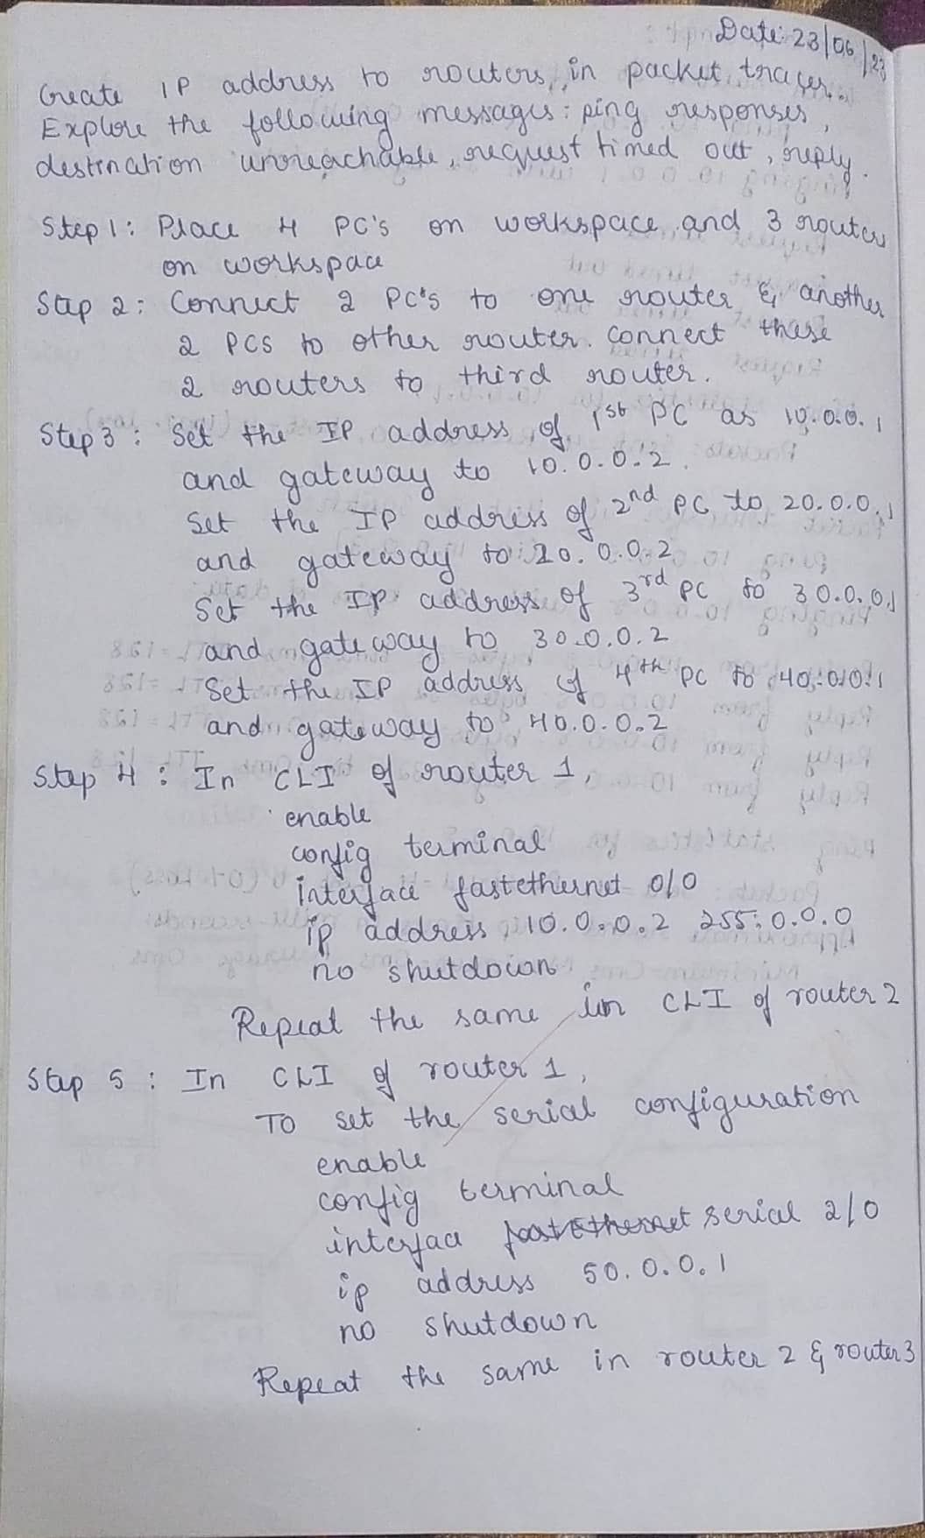

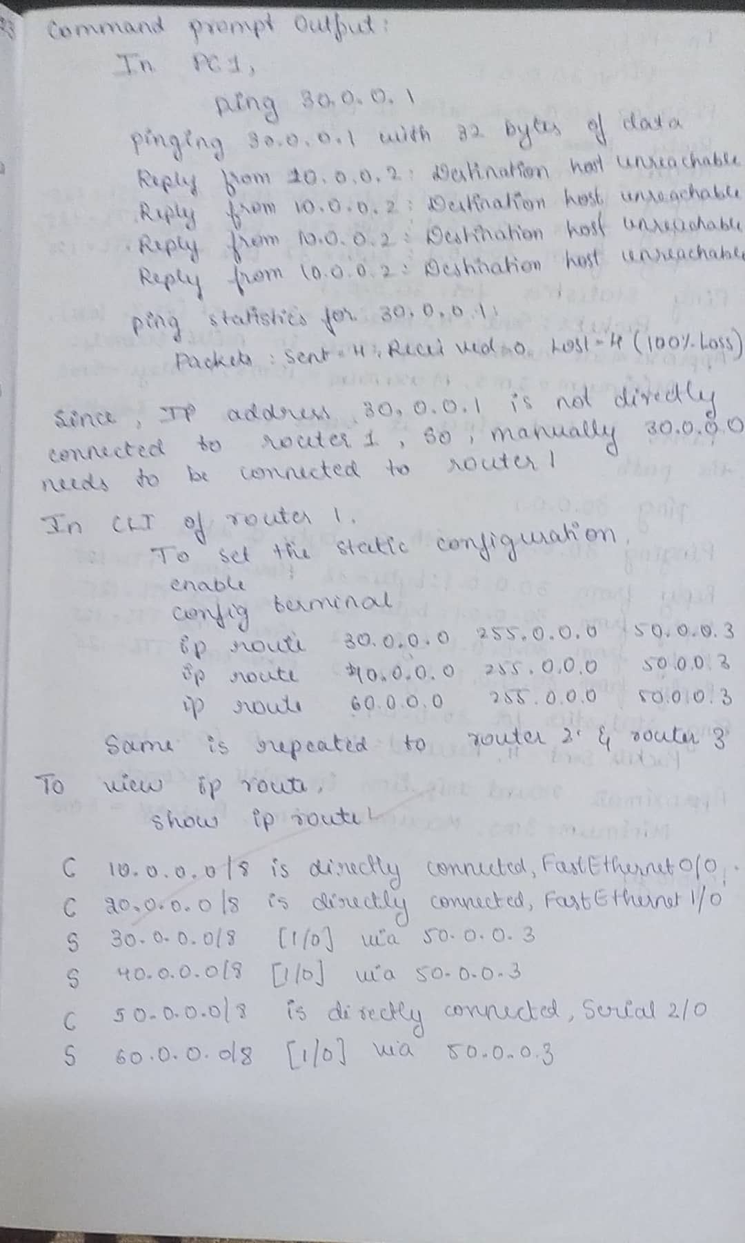

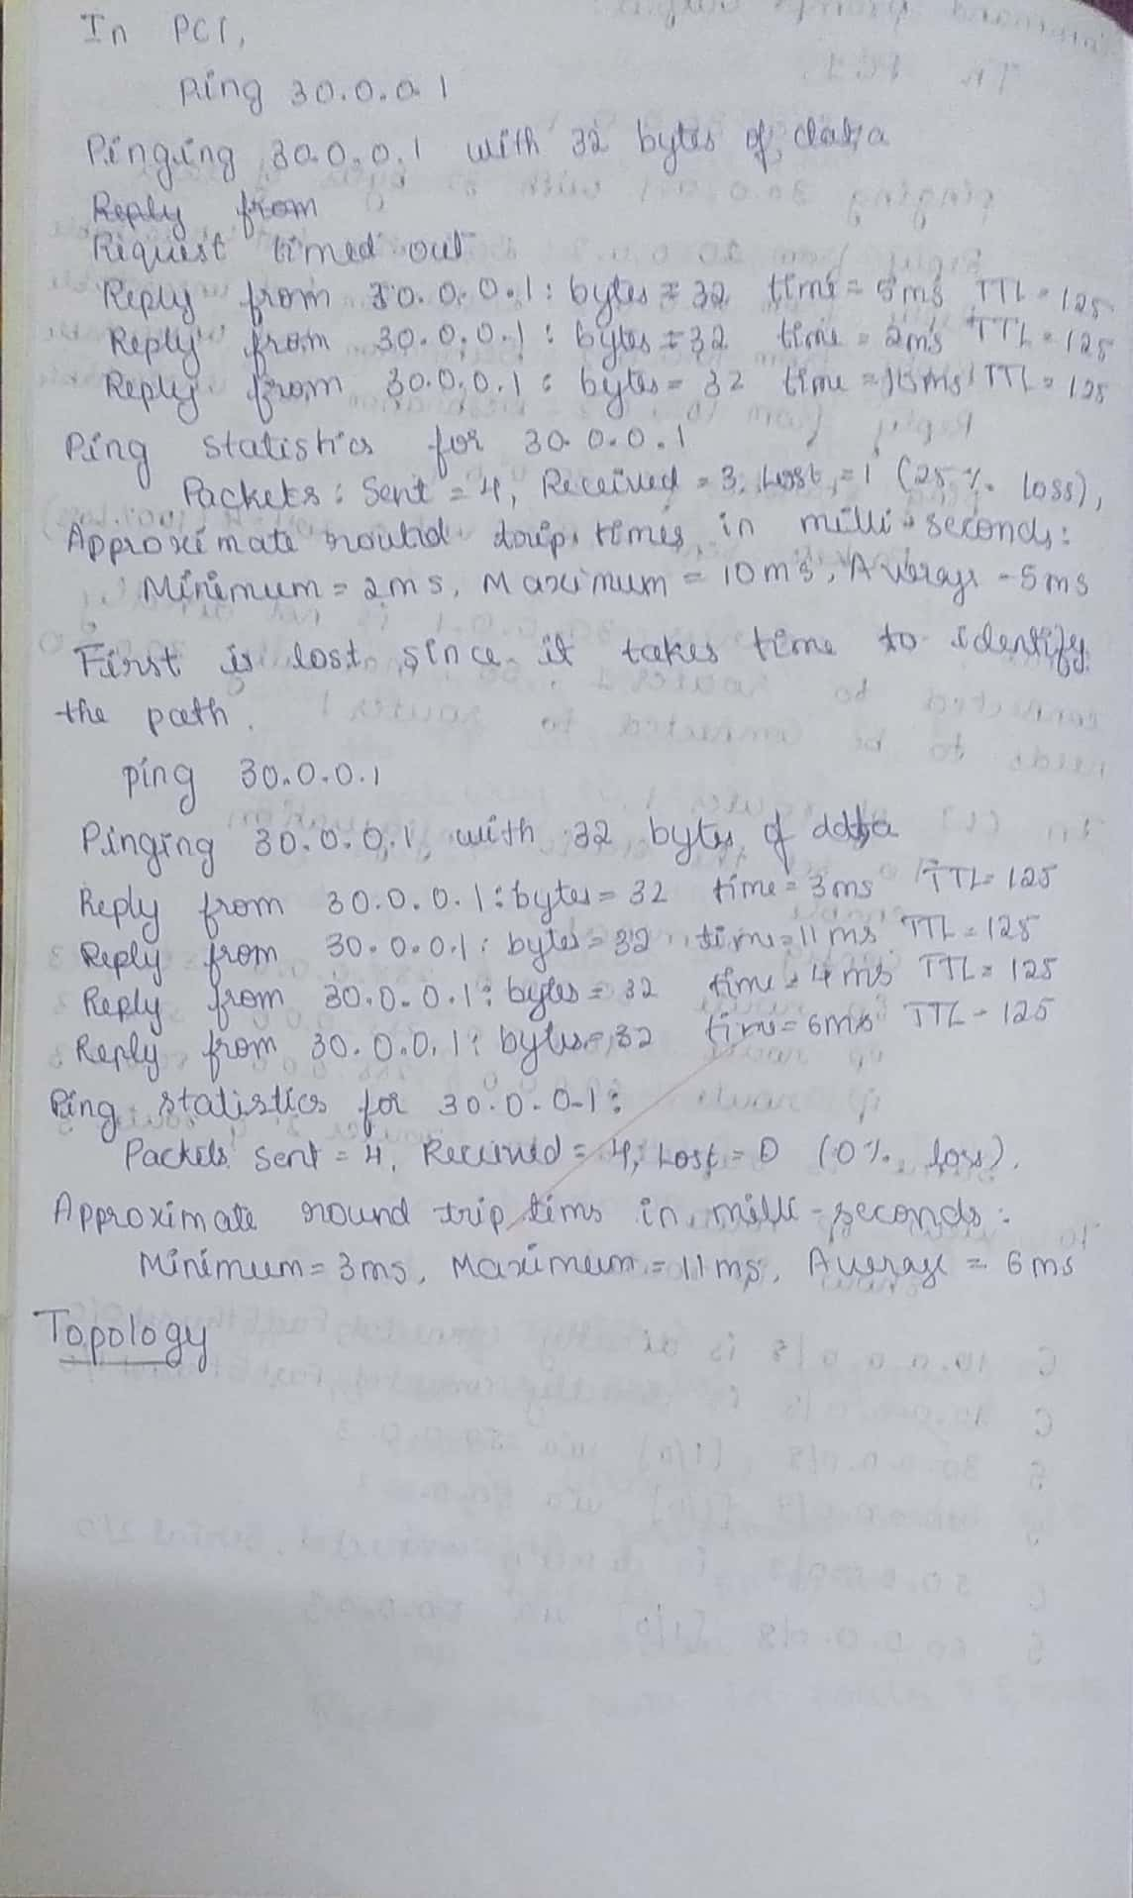

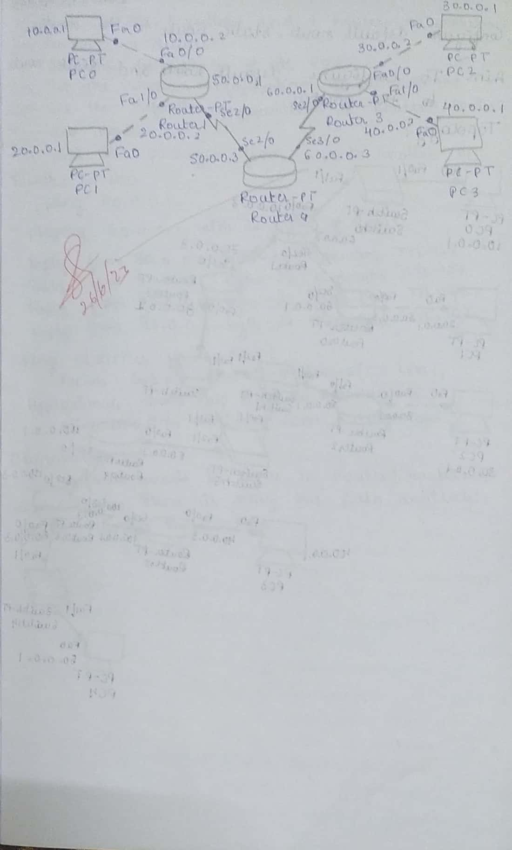

**Topology:**

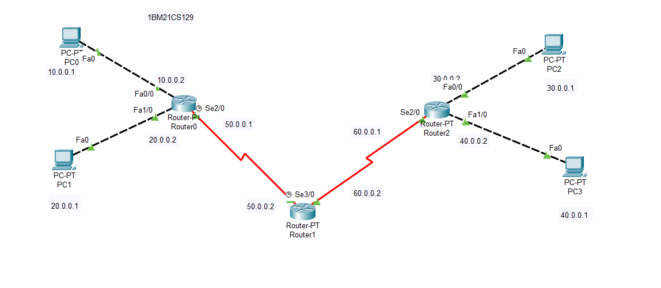

**Output:**

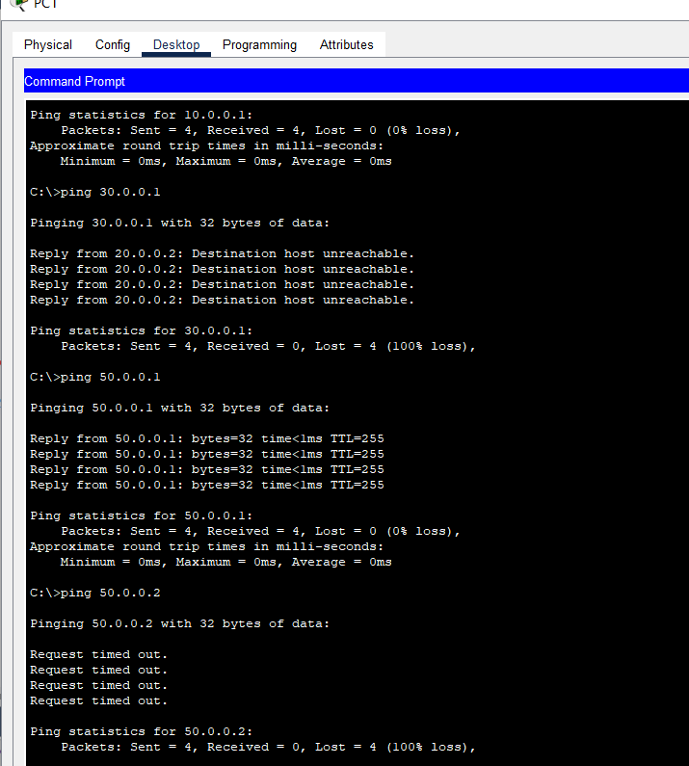

**Experiment 3**

**Configure default route, static route to the Router**

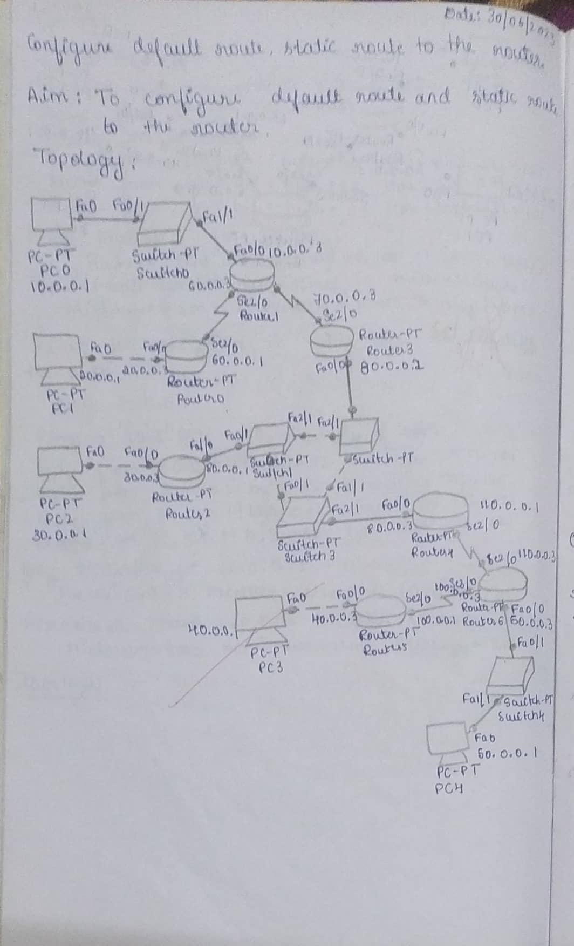

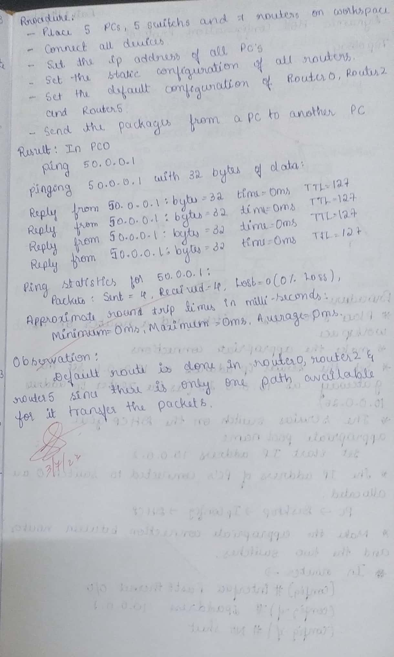

**Topology:**

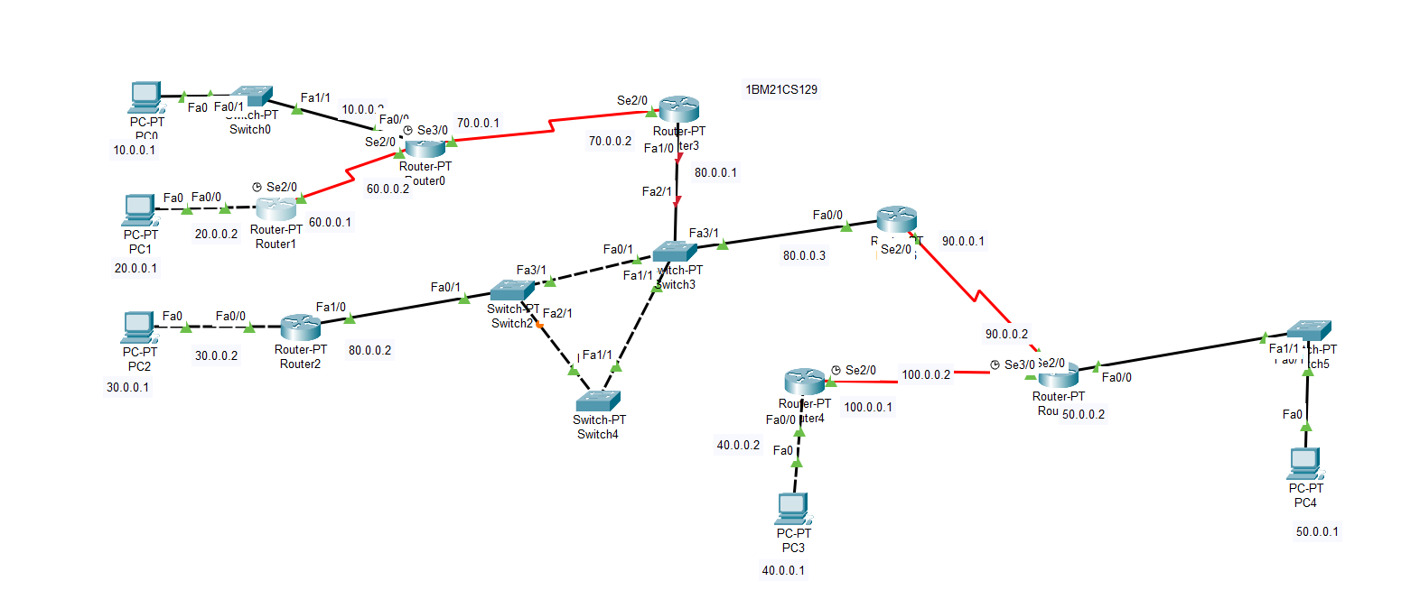

**Output:**

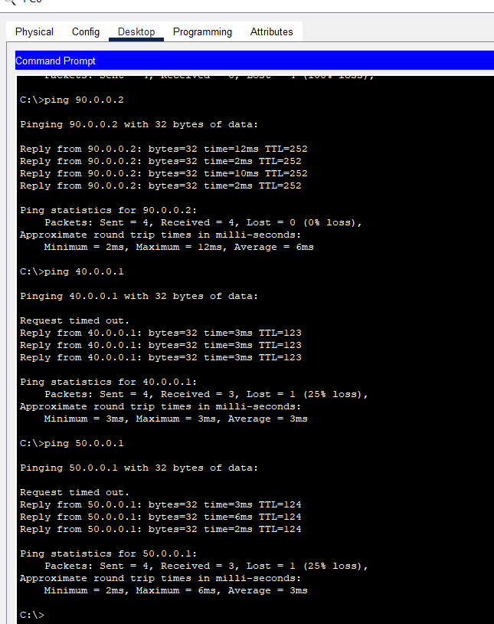

**Experiment 4**

**Configure DHCP within a LAN and outside LAN**

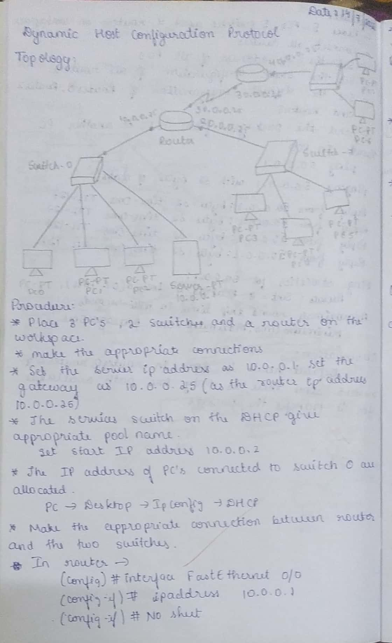

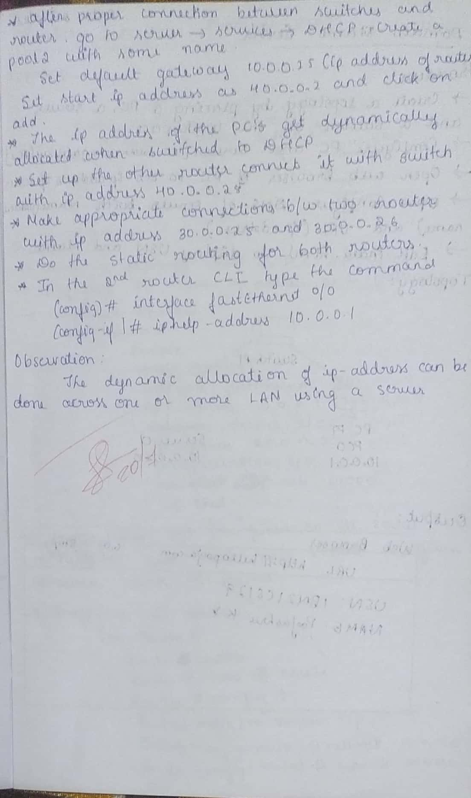

**Topology:**

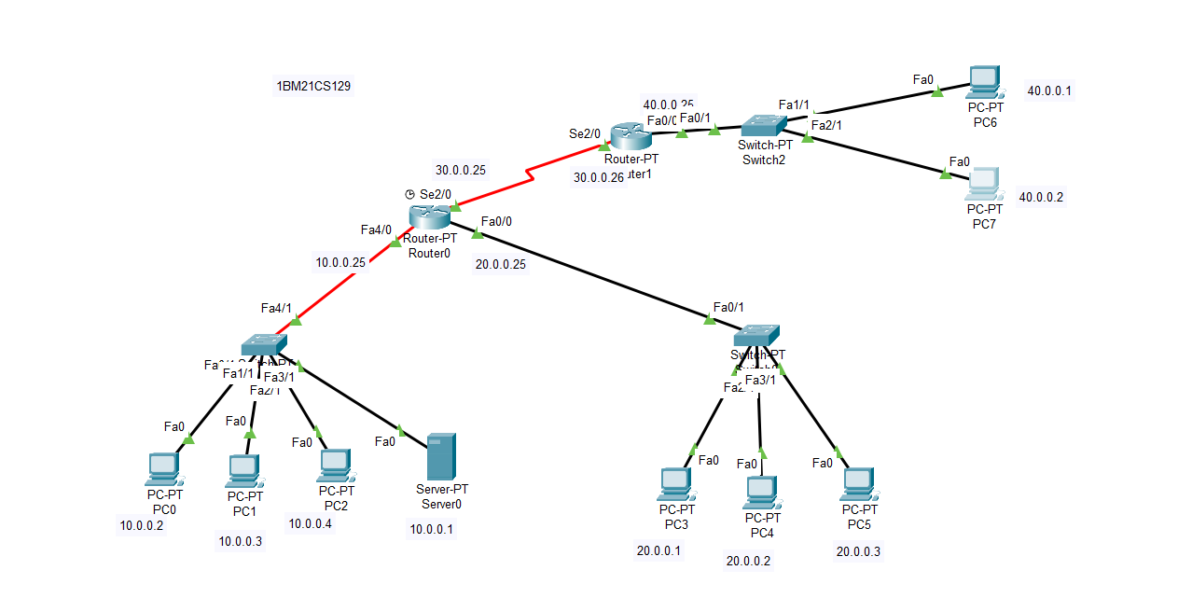

**Output:**

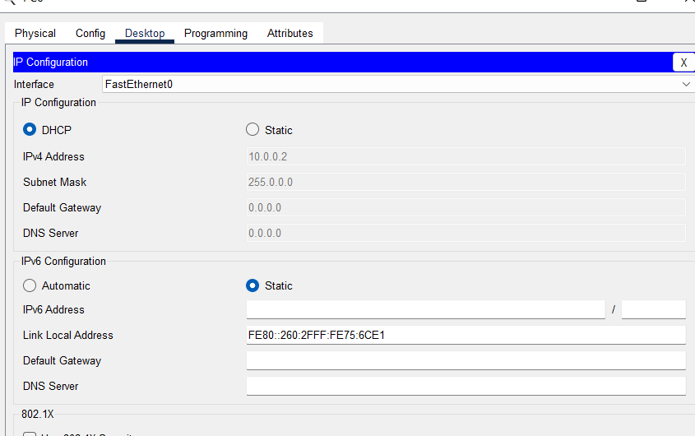

**Experiment 5**

**Configure RIP routing Protocol in Routers**

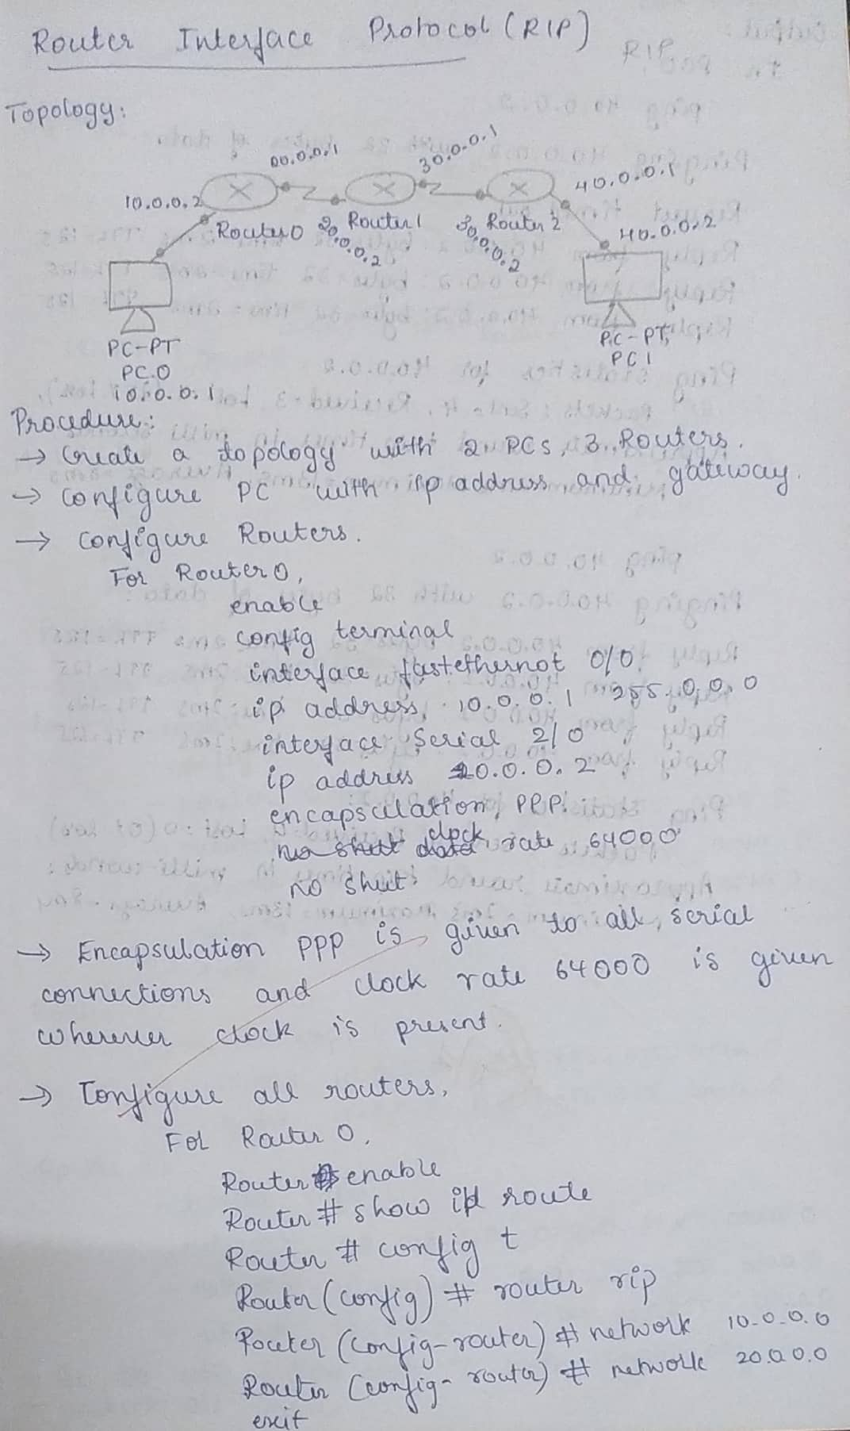

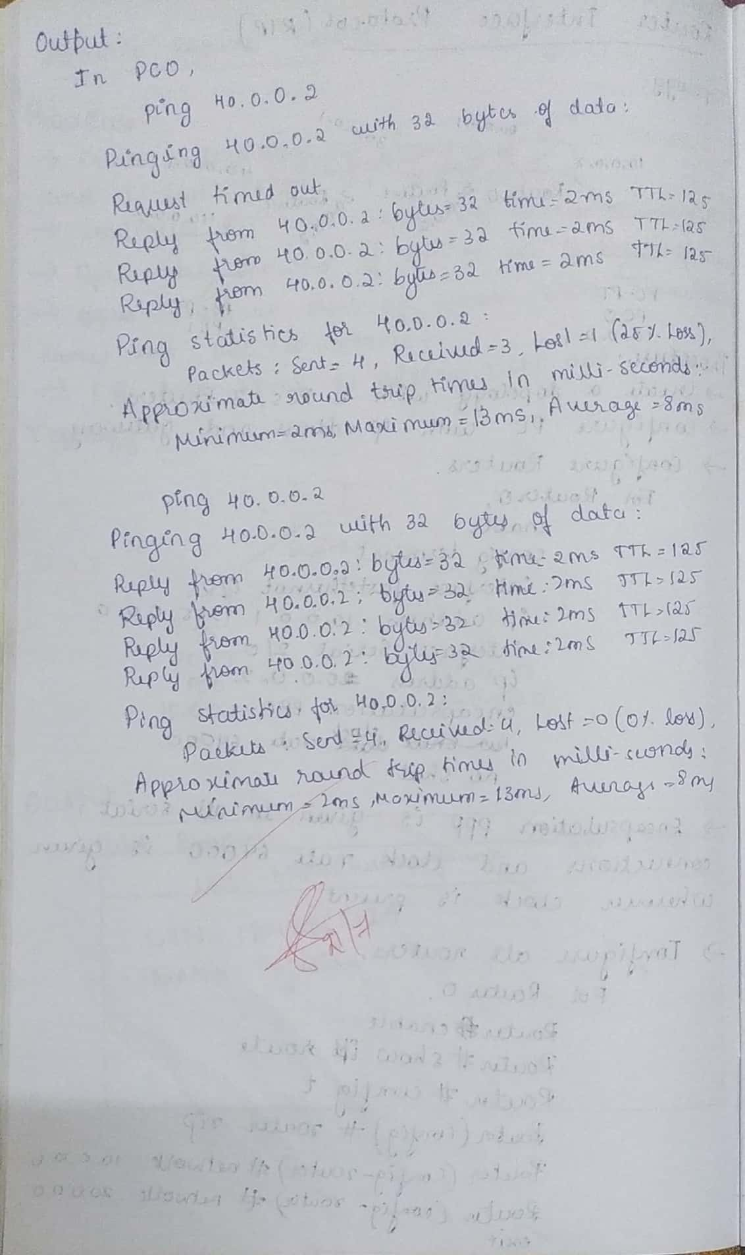

**Topology:**

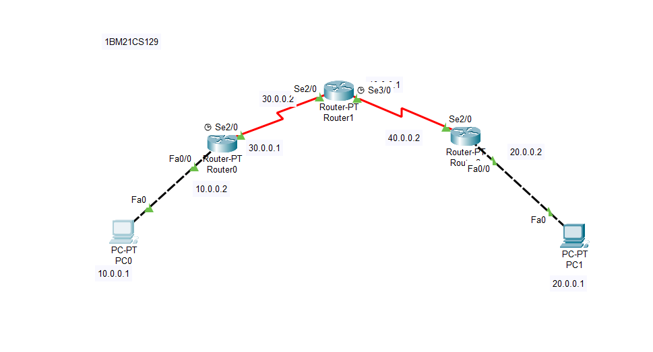

**1BM21CS1311BM21CS131**

**Output:**

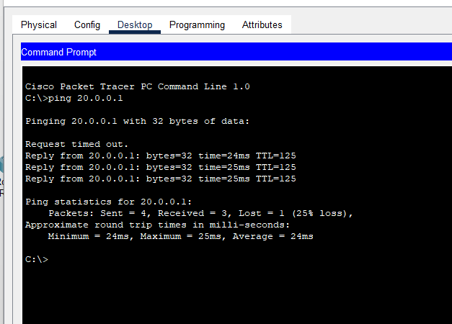

**Experiment 6**

**Configure OSPF routing protocol**

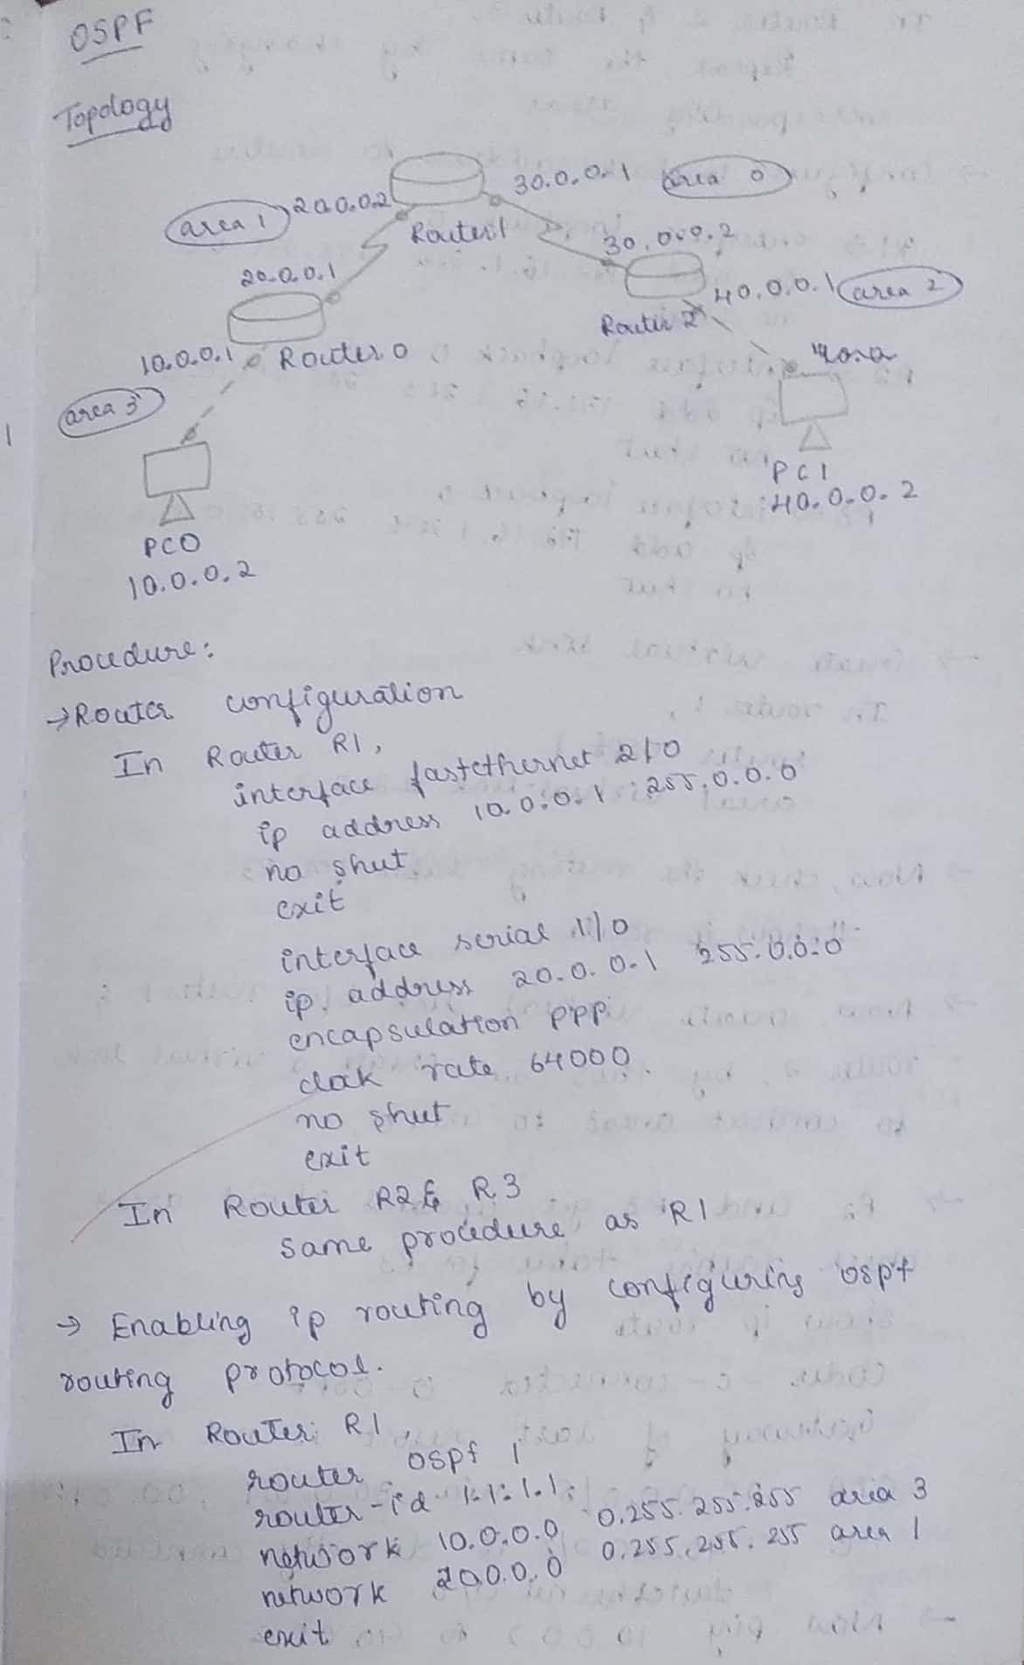

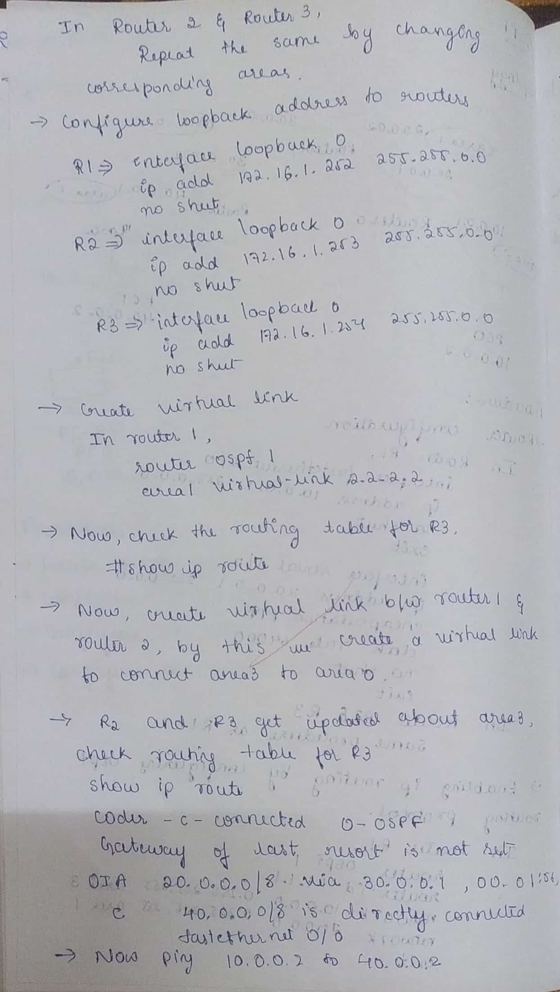

**Topology:**

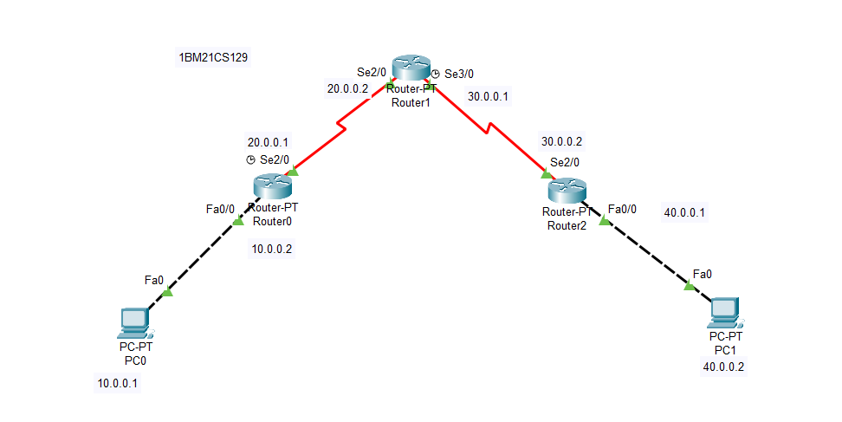

**Output:**

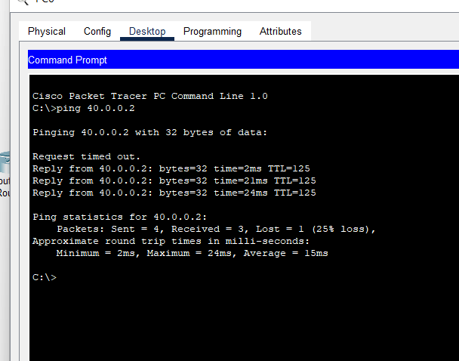

**Experiment 7**

**Demonstrate the TTL/ Life of a Packet**

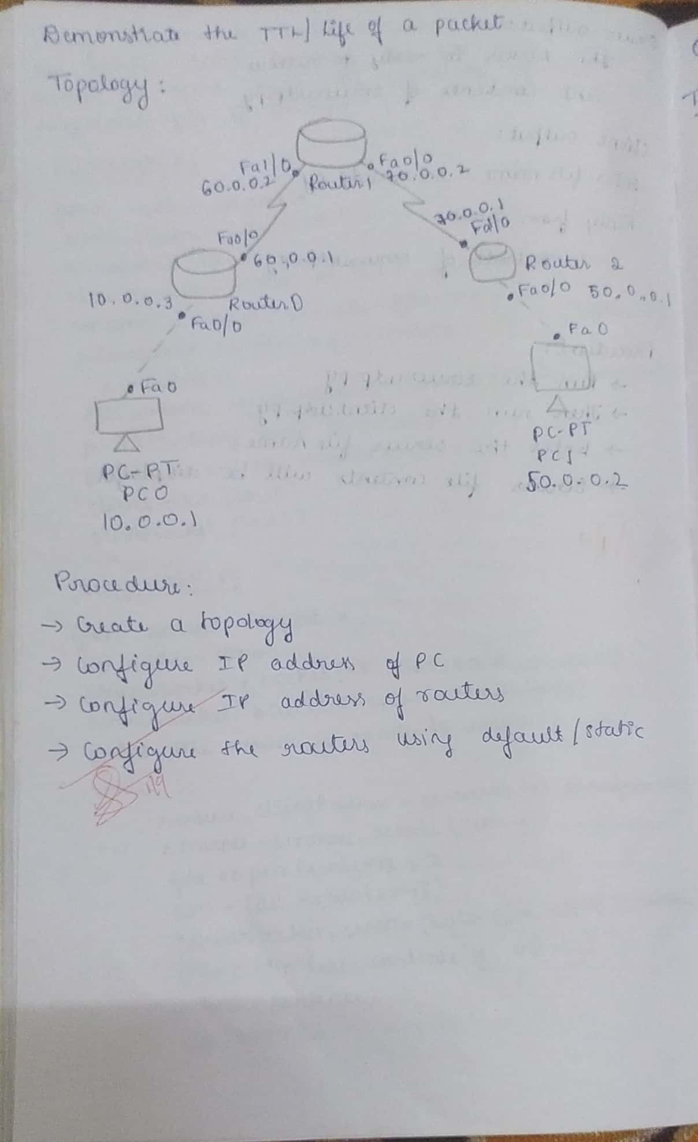

**Topology:**

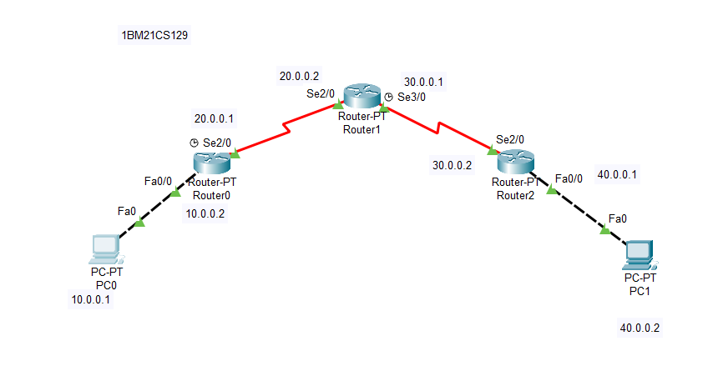

**Output:**

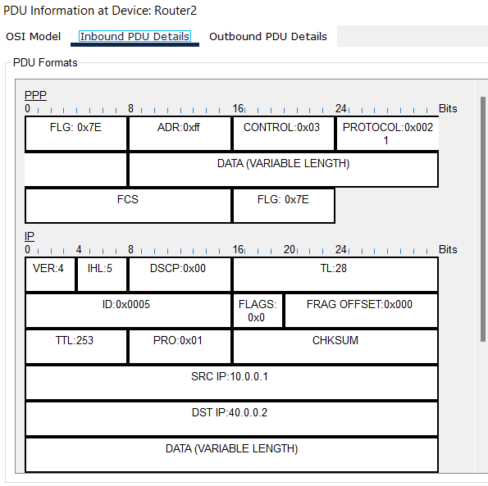

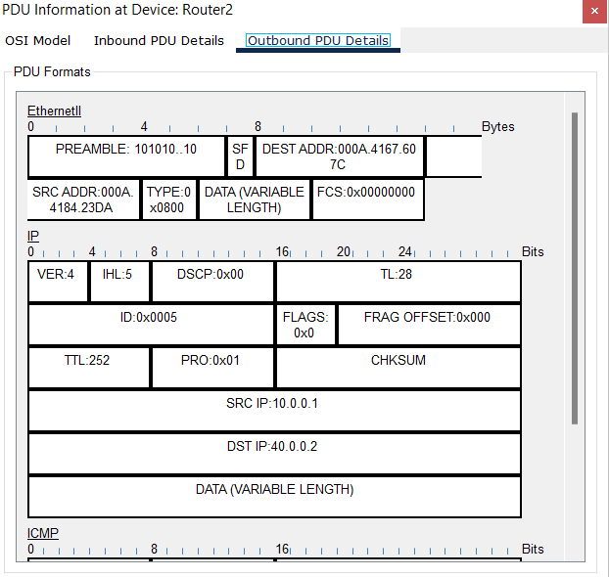

**Experiment 8**

**Configure Web Server, DNS within a LAN.**

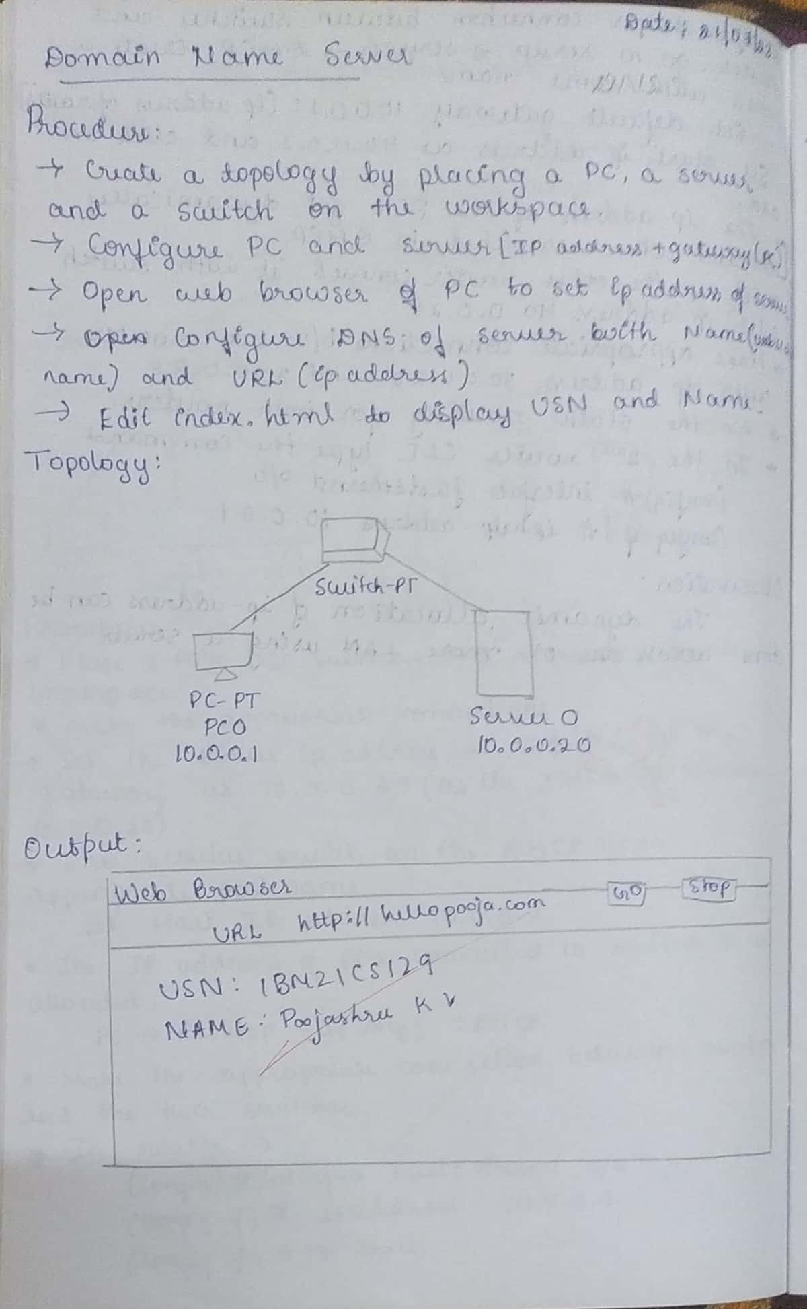

**Topology:**

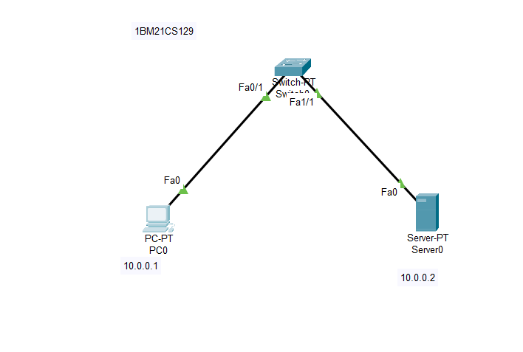

**Output:**

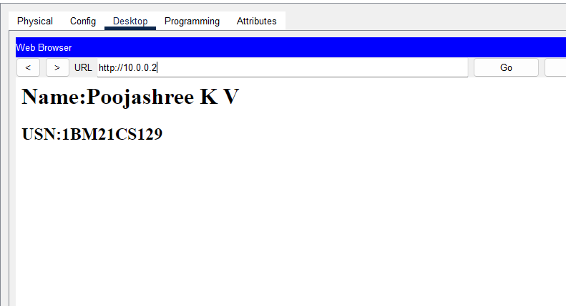

**USN:1BM21CS131**

**Name: Pradyumna Rao**

**Experiment 9**

**To construct simple LAN and understand the concept and operation of Address Resolution Protocol (ARP)**

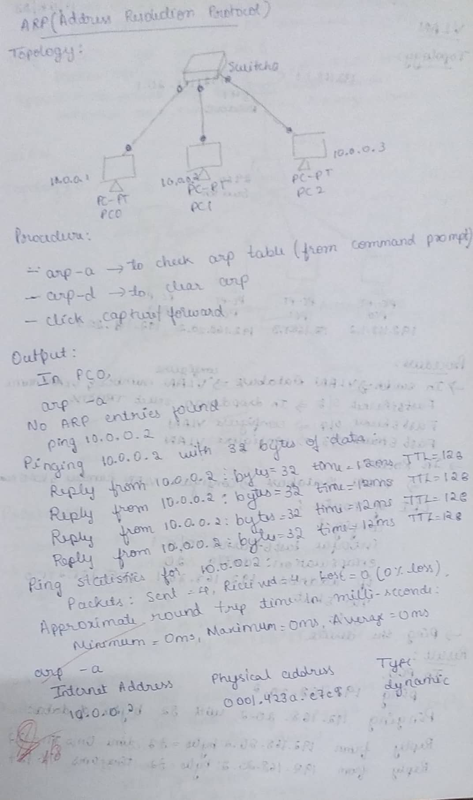

**Topology:**

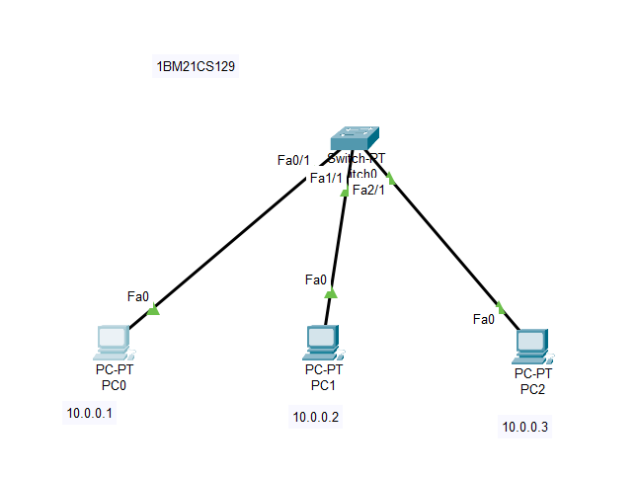

**Output:**

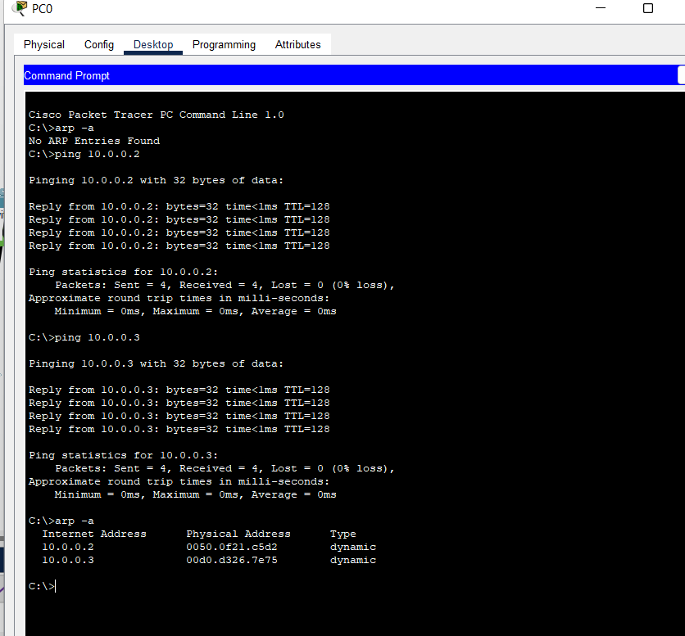

**Experiment 10**

**To understand the operation of TELNET by accessing the router in server room from a PC in IT office.**

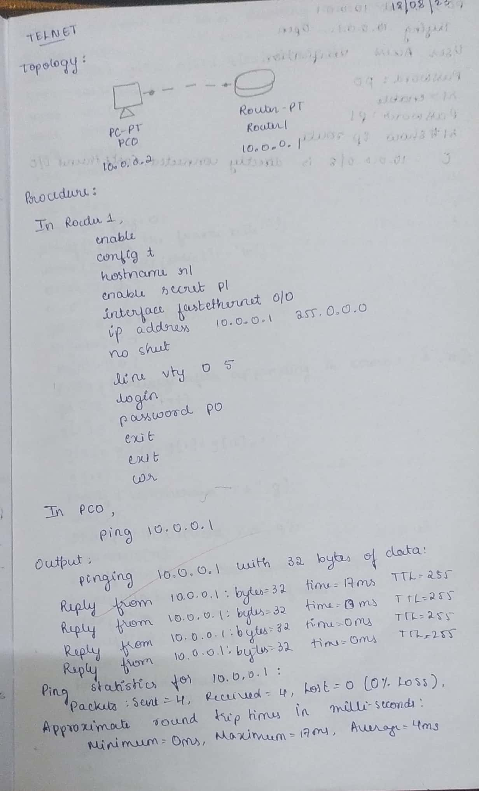

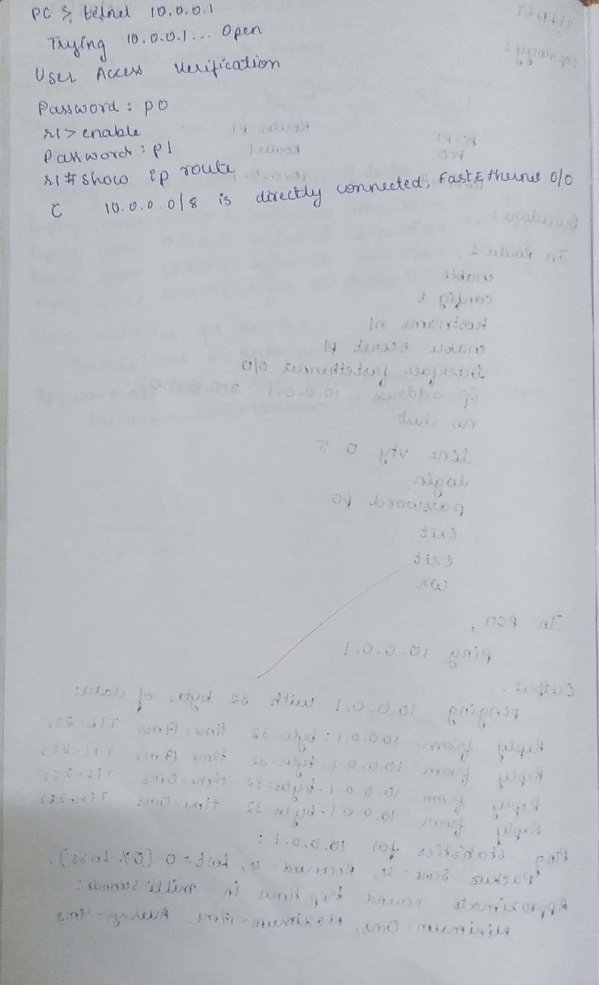

**Topology:**

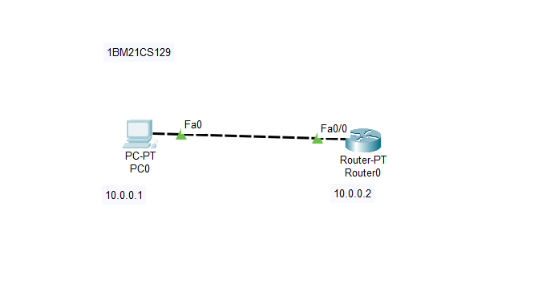

**Output:**

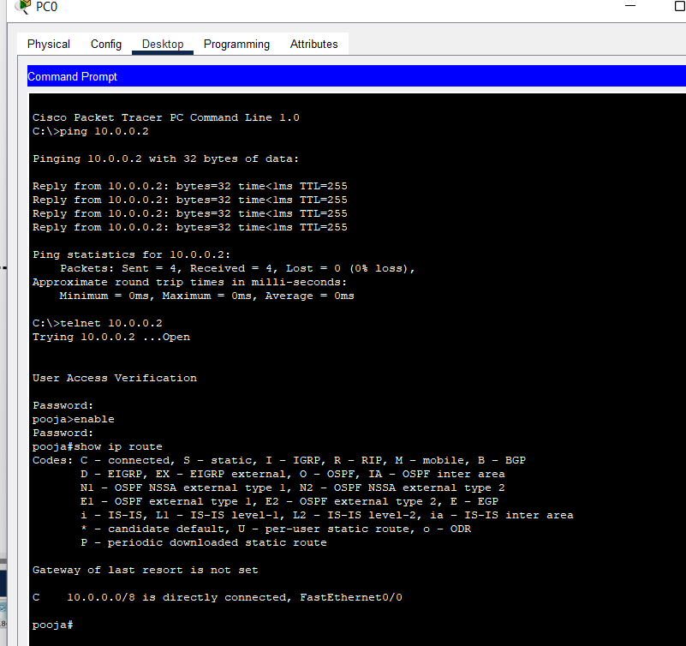

**Experiment 11**

**To construct a VLAN and make the PC’s communicate among a VLAN**

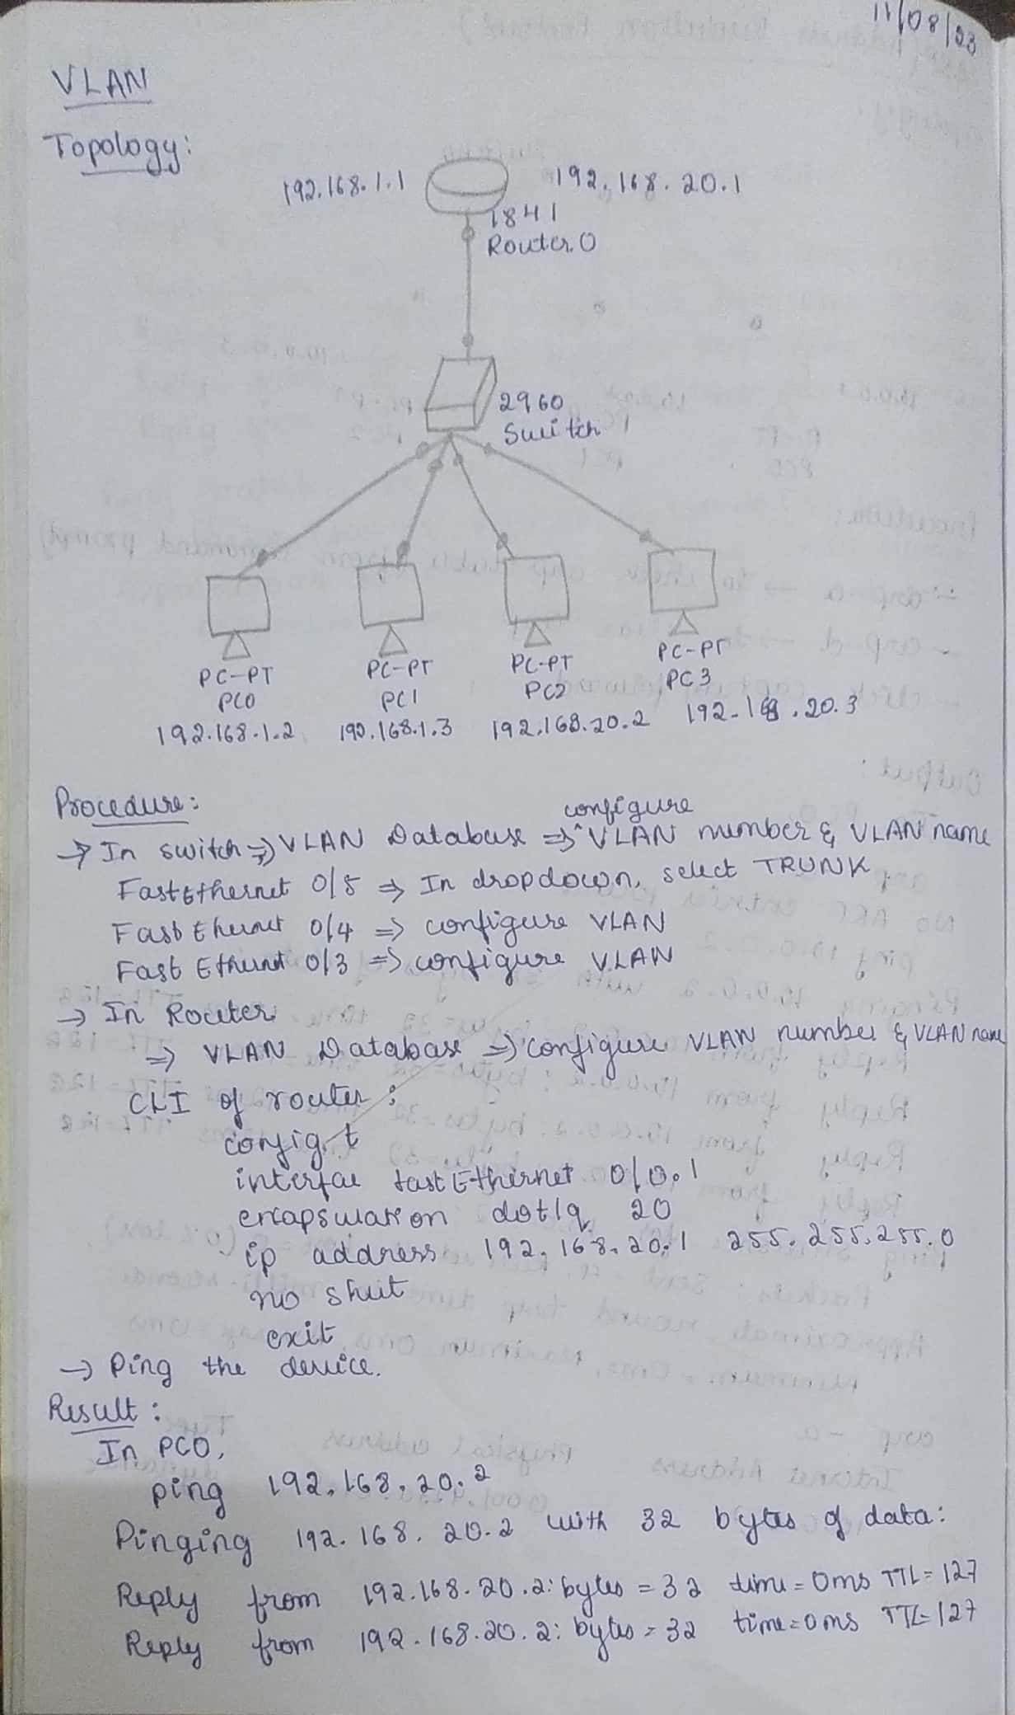

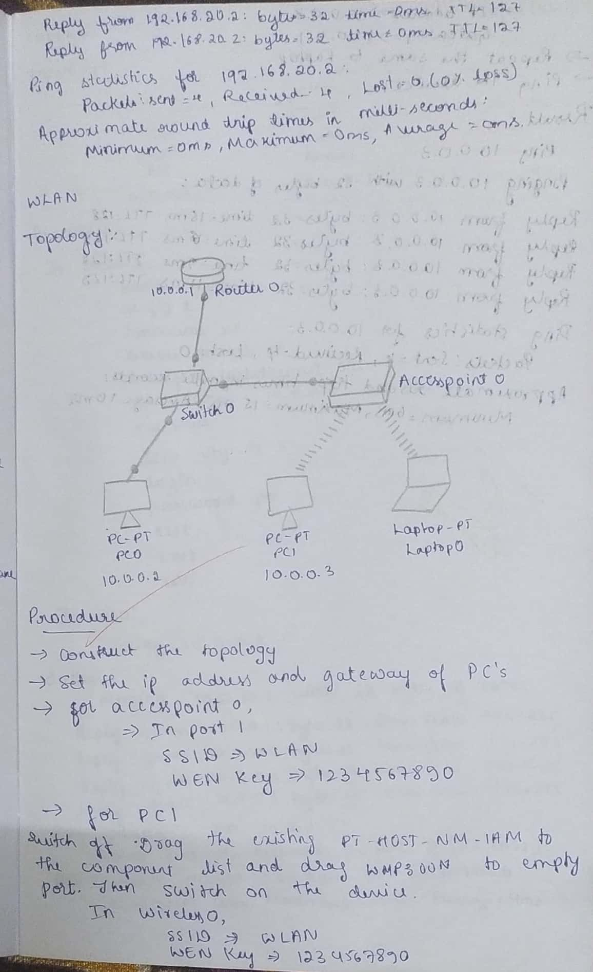

**Topology:**

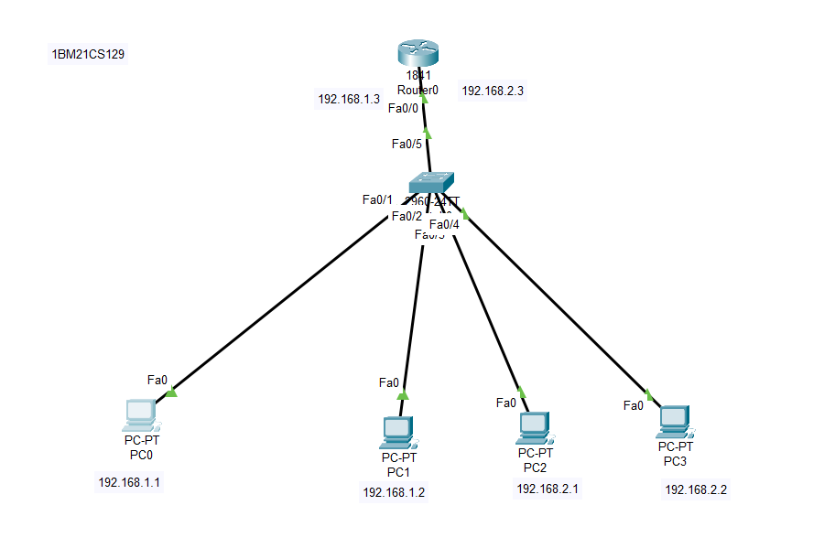

**Output:**

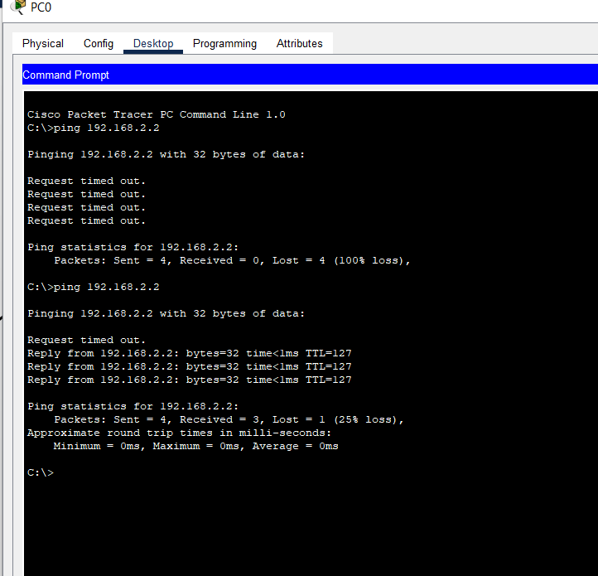

**Experiment 12**

**To construct a WLAN and make the nodes communicate wirelessly**



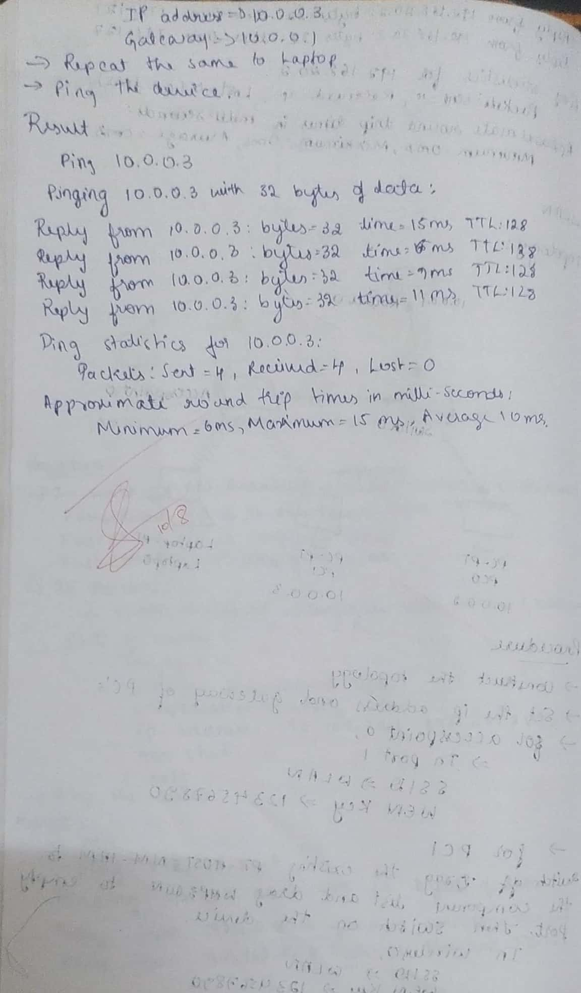

**Topology:**

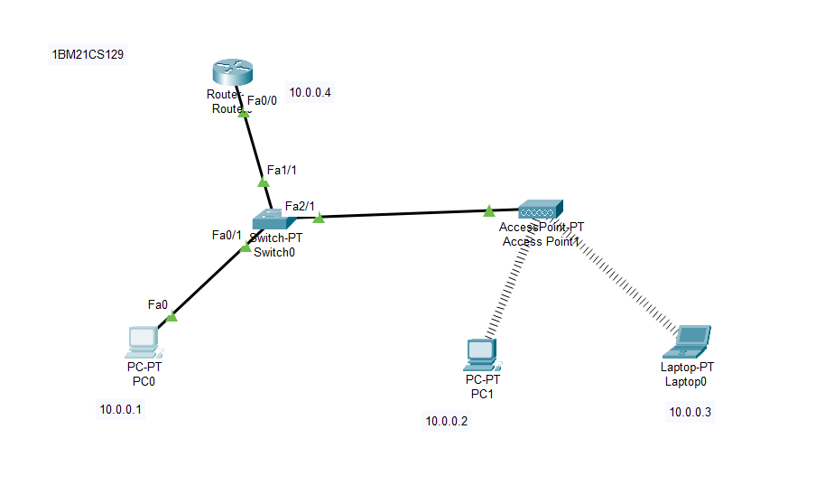

**Output:**

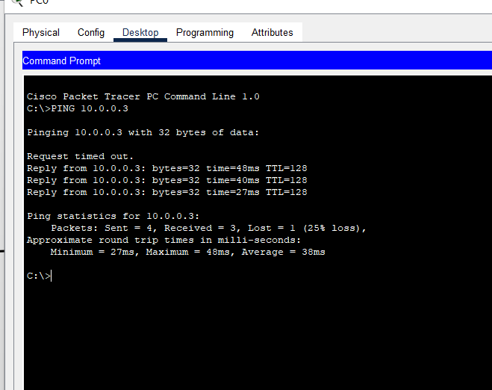

**Experiment 13**

**Write a program for error detecting code using CRCCCITT (16-bits).**

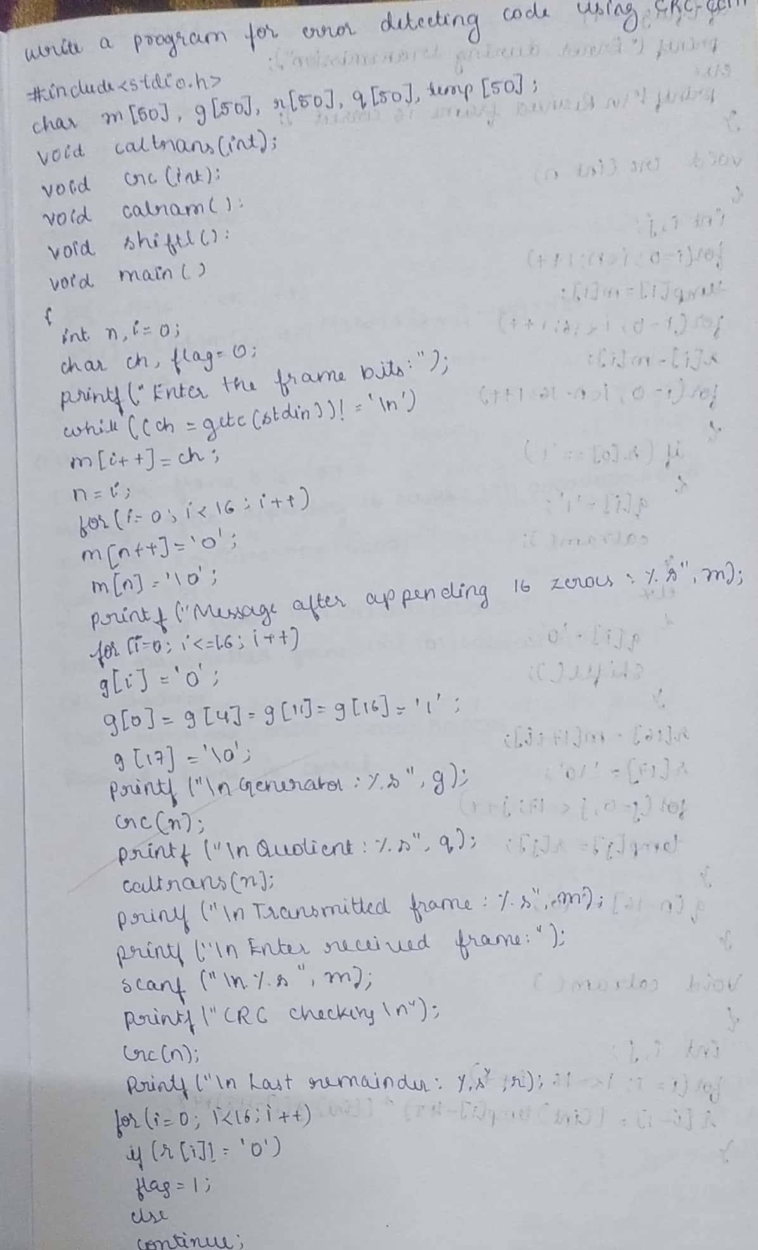

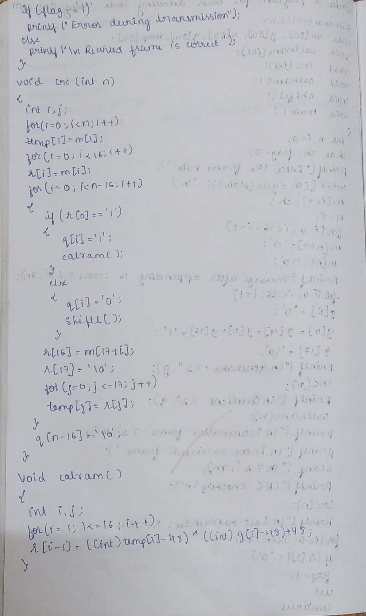

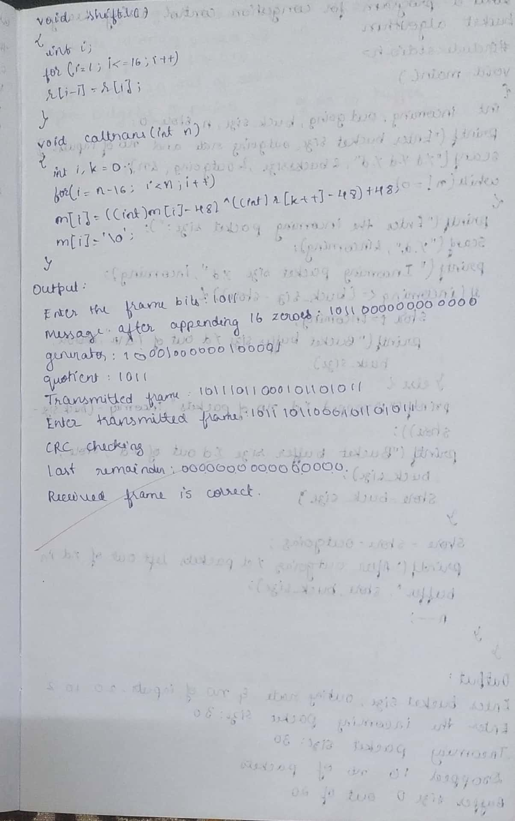

**Output:**

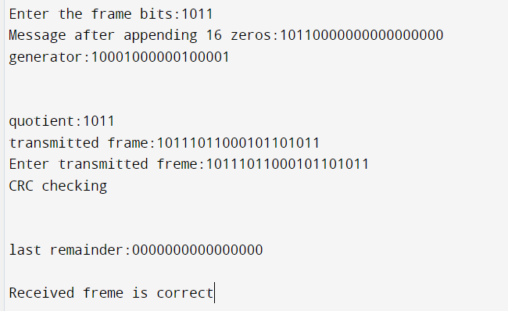

**Experiment 14**

**Write a program for congestion control using Leaky bucket algorithm.**

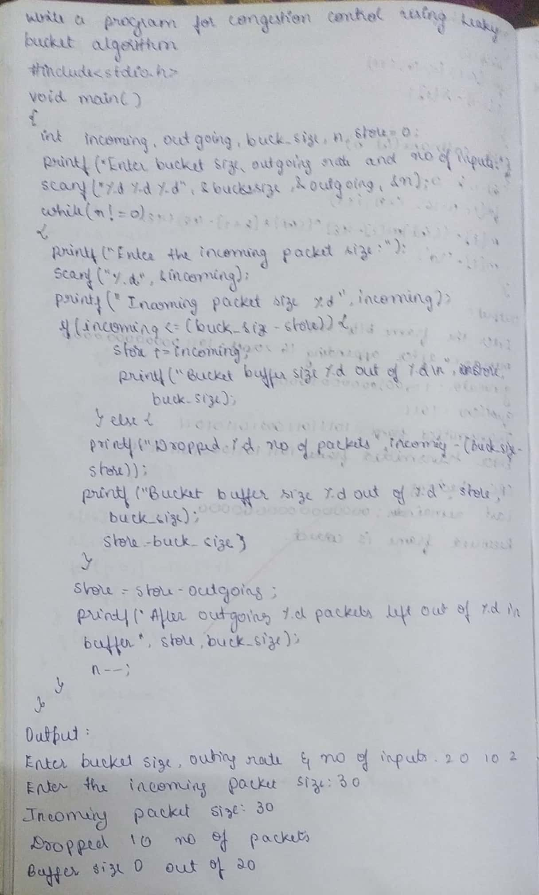

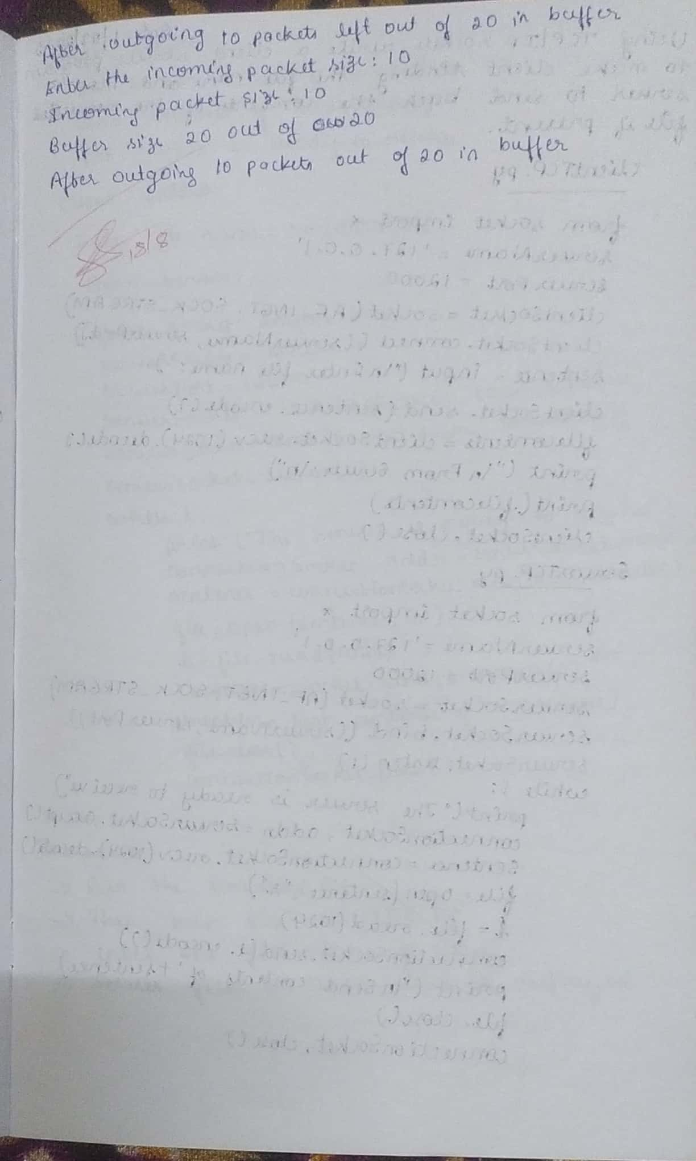

**Output:**

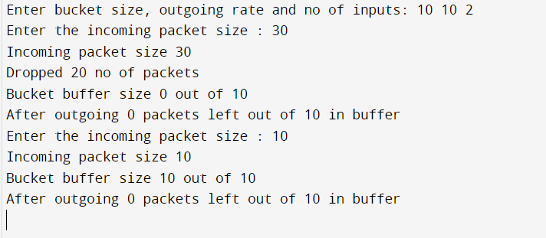

**Experiment 15**

**Using TCP/IP sockets, write a client-server program to make client sending the file name and the server to send back the contents of the requested file if present**

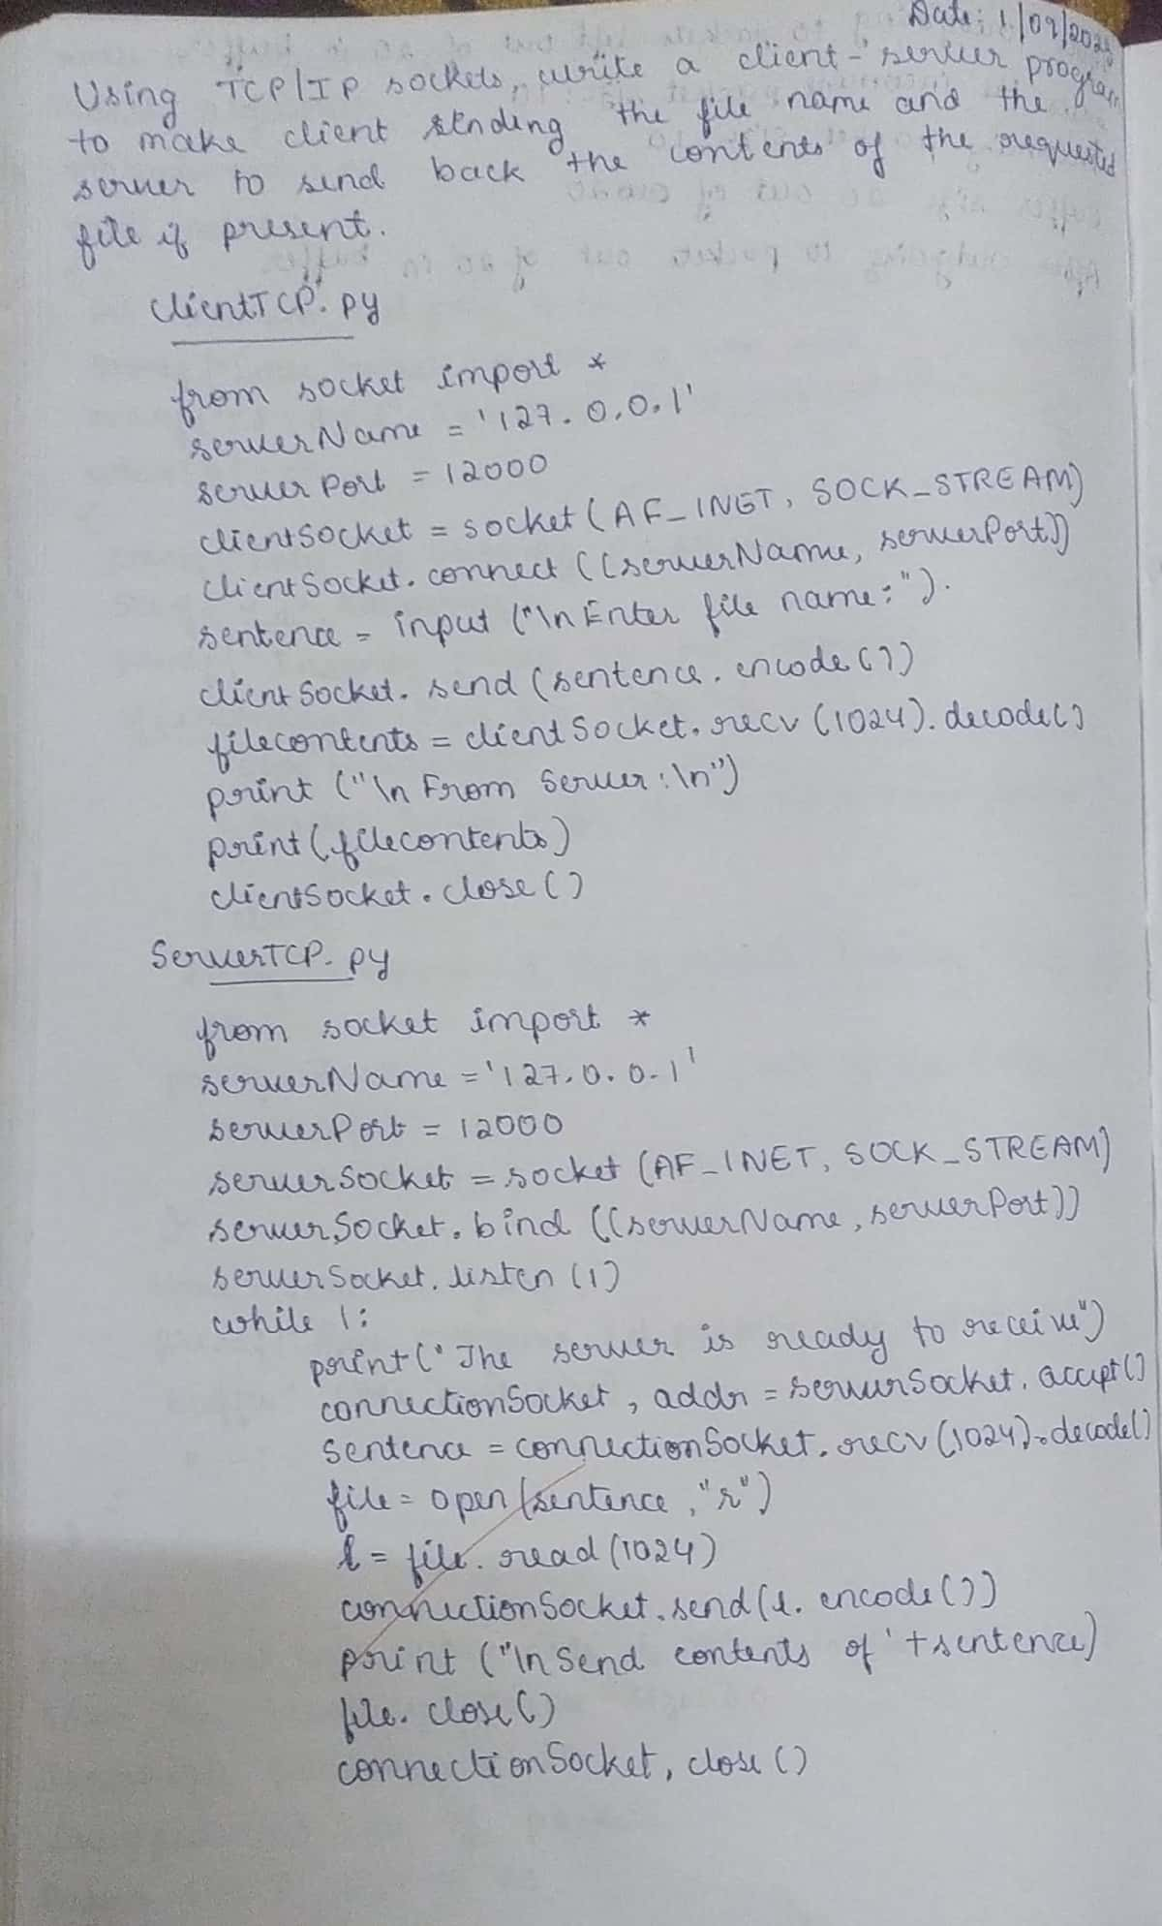

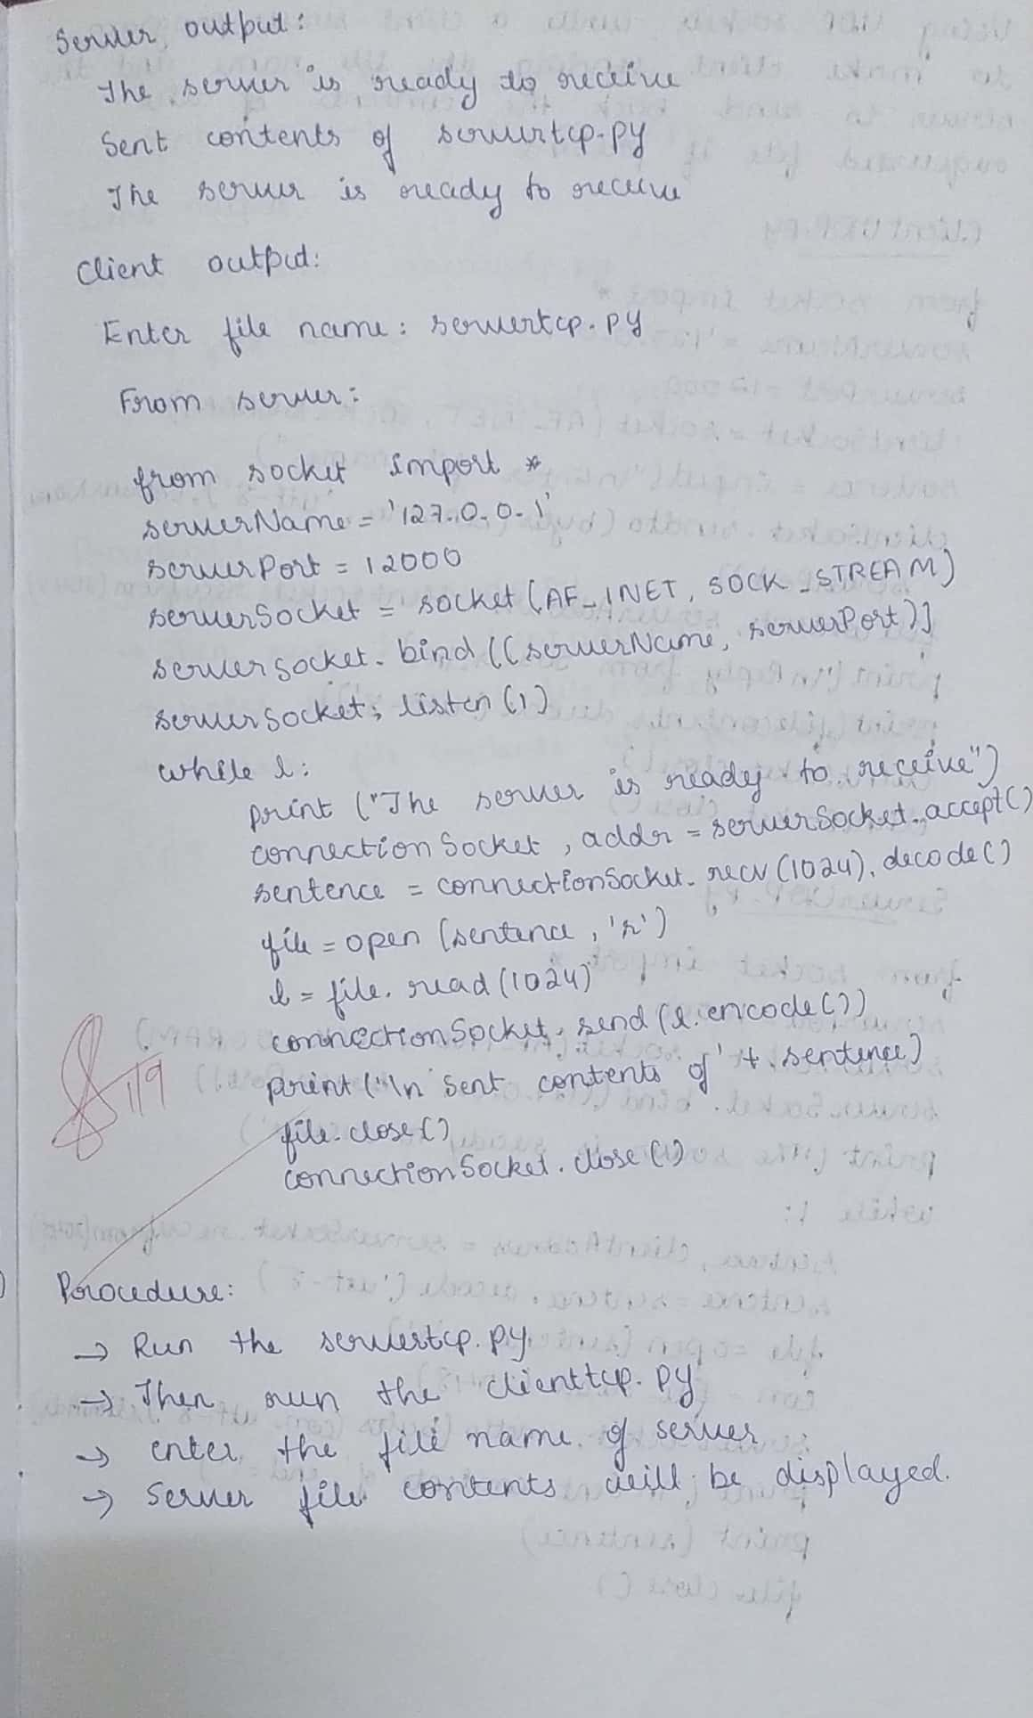

**Output:**

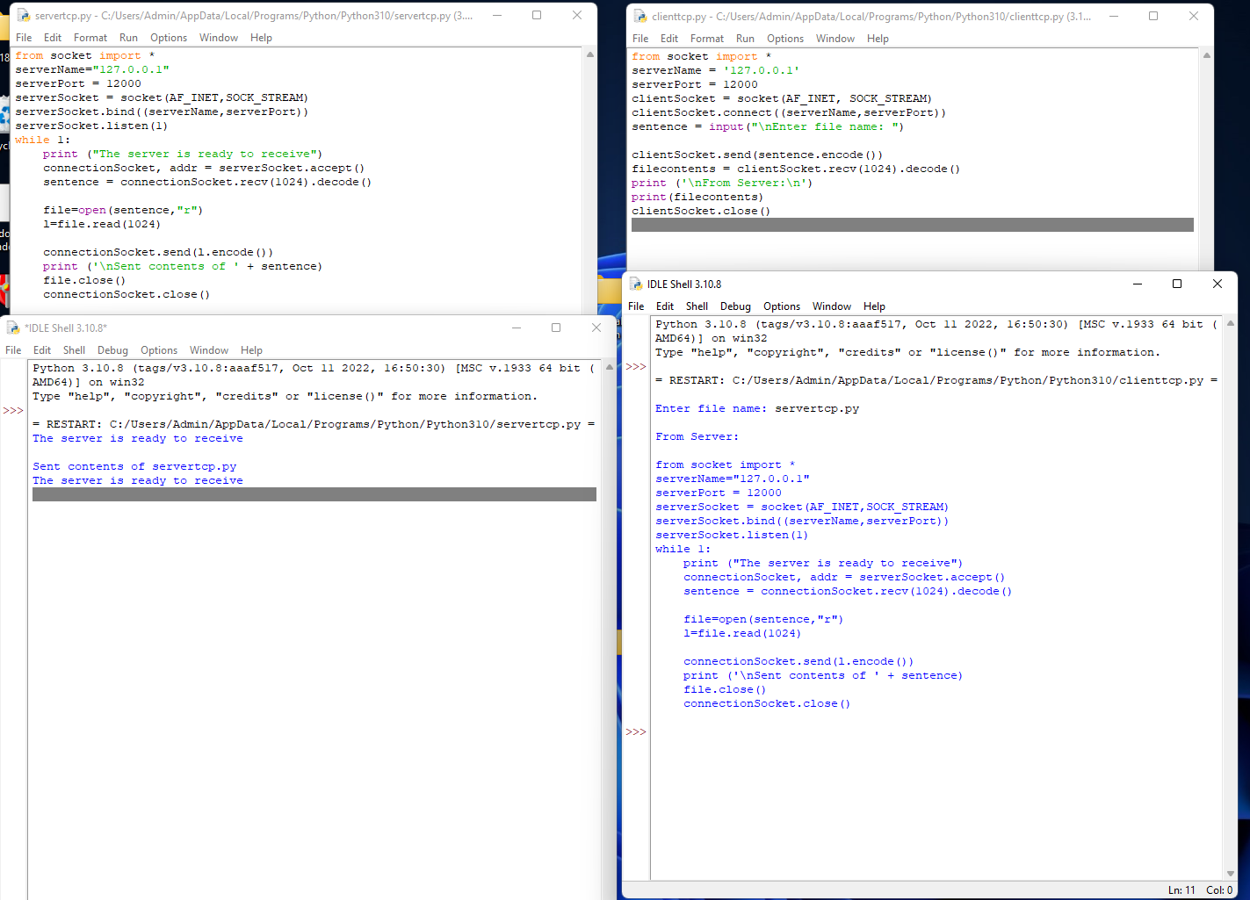

**Experiment 16**

**Using UDP sockets, write a client-server program to make client sending the file name and the server to send back the contents of the requested file if present**

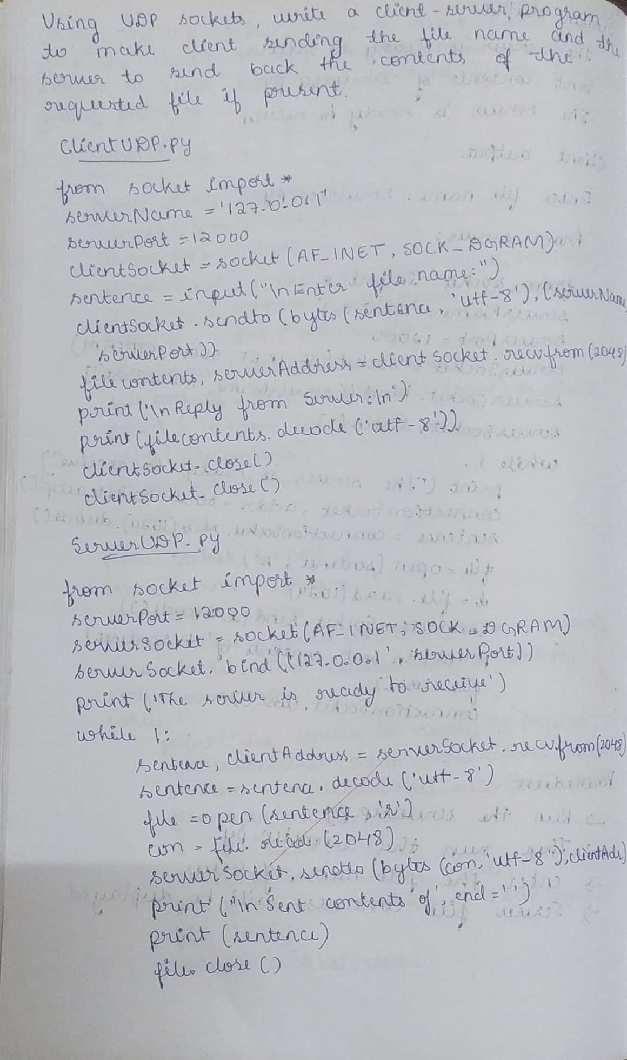

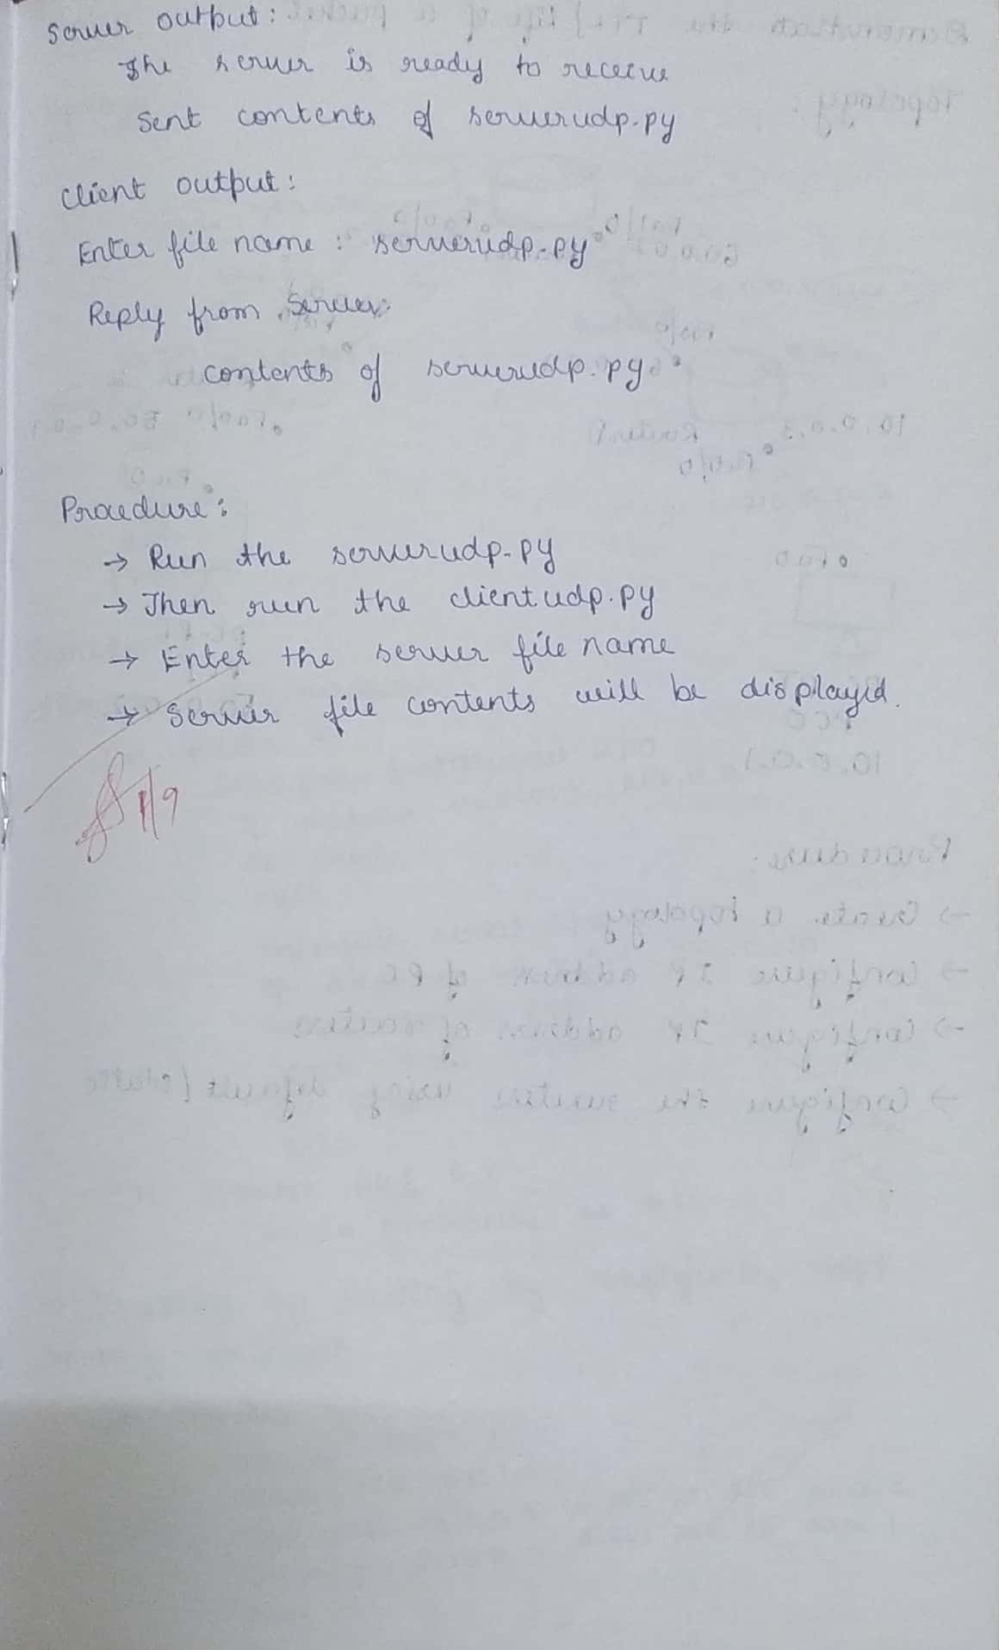

**Output:**

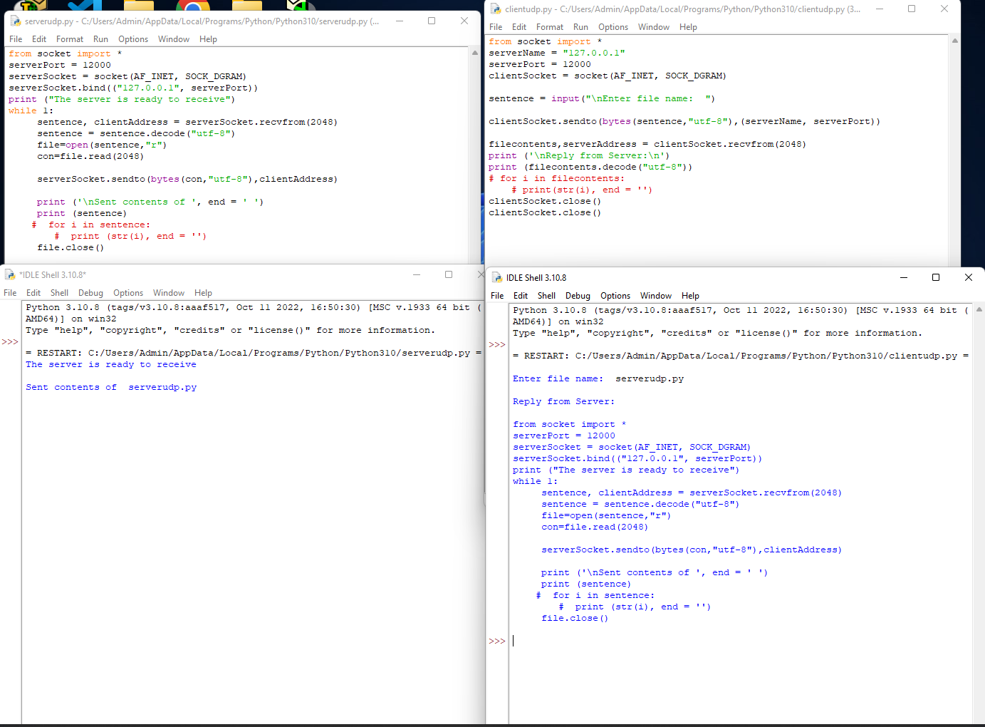**s**

**Experiment 17**

**Tool Exploration -Wireshark**

